GATE 2027
AGRICULTURAL ENGINEERING (AG)
FULL-LENGTH MOCK PAPER — SET 3
(with diagram- and graph-based questions)

Paper Code | AG (Agricultural Engineering)
Set Number | 3 (fresh rotation-pool selection and numerical data; distinct from Sets 1 and 2)
Duration | 180 minutes (3 hours)
Maximum Marks | 100
Total Questions | 65 (Q.1–Q.65)
Difficulty Calibration | HARD (one notch above actual GATE difficulty, within syllabus scope)
Diagrams/Graphs | 12 figure references across 11 diagram-bearing questions (line chart, rotation-series spatial puzzle, definite-integral shaded-area graph, disc-plough geometry, belt-pulley wrap diagram, tractive-effort-vs-slip curve, Horton infiltration curve, V-notch weir, Cooper-Jacob semi-log drawdown plot, psychrometric process diagram, counter-current heat-exchanger profile) — see Q.5, Q.10, Q.16, Q.18, Q.36, Q.44, Q.49, Q.50, Q.56, Q.60, Q.63, Q.65 — all fresh diagram types, distinct from Set 2 figures

Instructions to Candidates
1. General Aptitude (GA): Q.1–Q.10 carry a total of 15 marks. Q.1–Q.5 carry 1 mark each; Q.6–Q.10 carry 2 marks each. GA consists entirely of MCQs.
2. Agricultural Engineering subject (including Engineering Mathematics): Q.11–Q.65 carry a total of 85 marks. Q.11–Q.35 carry 1 mark each; Q.36–Q.65 carry 2 marks each.
3. Question types: MCQ (four options, exactly one correct), MSQ (four options, one or more correct — no negative marking, no partial credit), and NAT (numerical answer type — no options, answer to be entered directly).
4. Negative marking (MCQ only): −1/3 mark for a wrong answer to a 1-mark MCQ; −2/3 mark for a wrong answer to a 2-mark MCQ. There is no negative marking for MSQ or NAT questions.
5. All quantities are in SI units unless stated otherwise. Where a figure would normally accompany a question, a complete word description with all necessary numerical data is provided in its place.

Question Paper
Q.1 – Q.10 : General Aptitude (GA)
Q.1 [1 mark] [MCQ]
A cooperative pays compound interest at 10% per annum (compounded annually) on farmer deposits. If a farmer deposits Rs 50,000, what is the amount after 2 years?
(A) Rs 55,000
(B) Rs 58,000
(C) Rs 60,500
(D) Rs 63,000

Q.2 [1 mark] [MCQ]
The average yield of 5 plots is 42 quintals/ha. If a sixth plot with a yield of 60 quintals/ha is added to the group, what is the new average yield of all 6 plots?
(A) 43 quintals/ha
(B) 44 quintals/ha
(C) 45 quintals/ha
(D) 46 quintals/ha

Q.3 [1 mark] [MCQ]
Choose the pair that best expresses a relationship similar to that expressed by the pair: DROUGHT : IRRIGATION
(A) Disease : Vaccination
(B) Rain : Cloud
(C) Fire : Heat
(D) Wind : Storm

Q.4 [1 mark] [MCQ]
A is B's sister. C is A's husband. How is C related to B?
(A) Brother
(B) Brother-in-law
(C) Uncle
(D) Cousin

Q.5 [1 mark] [MCQ]
The line graph below shows the retail diesel price (Rs/L) recorded at a village fuel pump over 6 consecutive months (January to June).
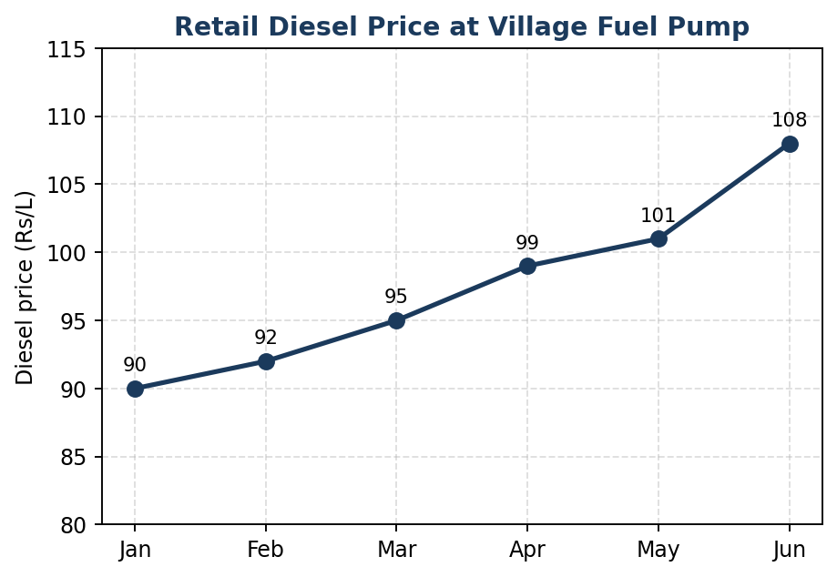
Figure: Retail diesel price (Rs/L), January–June
In which month was the PERCENTAGE increase in price over the previous month the highest?
(A) March
(B) April
(C) May
(D) June

Q.6 [2 marks] [MCQ]
A dealer marks up the price of a rotavator by 40% above cost price, then offers a discount of 20% on the marked price. If the final selling price is Rs 33,600, find the cost price.
(A) Rs 28,000
(B) Rs 29,000
(C) Rs 30,000
(D) Rs 32,000

Q.7 [2 marks] [MCQ]
A canal, if flowing continuously, can irrigate a field in 12 days. Due to a rotation schedule, water is supplied only on alternate days (supply on day 1, no supply on day 2, supply on day 3, and so on). How many total calendar days will it take to complete the irrigation?
(A) 21 days
(B) 22 days
(C) 23 days
(D) 24 days

Q.8 [2 marks] [MCQ]
Consider the statement: "Every irrigation project sanctioned by the state receives central funding ONLY IF it meets the minimum command area criterion. Project X, a state-sanctioned project, has received central funding."
Which one of the following can be logically concluded from this statement alone?
(A) Project X meets the minimum command area criterion.
(B) Project X does not meet the minimum command area criterion.
(C) No conclusion regarding the criterion can be drawn for Project X.
(D) All state-sanctioned projects meet the criterion.

Q.9 [2 marks] [MCQ]
Find the next term in the series: 3, 7, 15, 31, 63, ?
(A) 95
(B) 111
(C) 120
(D) 127

Q.10 [2 marks] [MCQ]
The figure below shows a sequence of four positions of an arrow-and-dot marker as it rotates by a FIXED angle at each successive step (0°, then rotated to 70°, then 140°, then 210°).
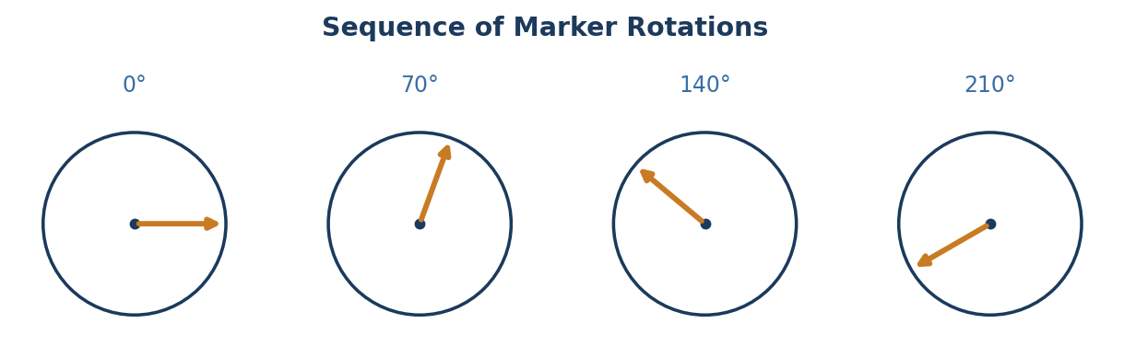
Figure: Sequence of marker rotations
If the pattern of rotation continues, through what additional angle (measured from the fourth position shown) must the marker further rotate to reach the fifth position in the sequence?
(A) 60°
(B) 70°
(C) 80°
(D) 90°

Q.11 – Q.65 : Agricultural Engineering (AG)
Q.11 [1 mark] [MCQ]
Find dy/dx for y = ln(x² + 1) at x = 1.
(A) 0.5
(B) 1
(C) 1.5
(D) 2

Q.12 [1 mark] [MCQ]
For the scalar field φ(x,y,z) = x²y + yz², find ∇φ at the point (1, 2, 1).
(A) (4, 2, 4)
(B) (2, 4, 2)
(C) (4, 4, 2)
(D) (2, 2, 4)

Q.13 [1 mark] [MCQ]
The matrix A = [[1, 2], [2, 4]] is singular. Why?
(A) Its rows are linearly dependent (Row 2 = 2 × Row 1), so det(A) = 0
(B) It is a symmetric matrix
(C) Its trace is zero
(D) It has complex eigenvalues

Q.14 [1 mark] [MCQ]
Which of the following is the integrating factor for the linear ODE: dy/dx − y/x = x² (for x > 0)?
(A) x
(B) 1/x
(C) x²
(D) 1/x²

Q.15 [1 mark] [MCQ]
The general solution of the differential equation d²y/dx² + 9y = 0 is:
(A) C₁ cos 3x + C₂ sin 3x
(B) C₁ e^(3x) + C₂ e^(−3x)
(C) (C₁ + C₂x) e^(3x)
(D) C₁ e^(3x) + C₂x e^(3x)

Q.36 [2 marks] [MCQ]
The figure below shows the graph of g(x) = 4x − x² over the interval [0,4], with the shaded region representing the definite integral ∫₀⁴ g(x) dx.
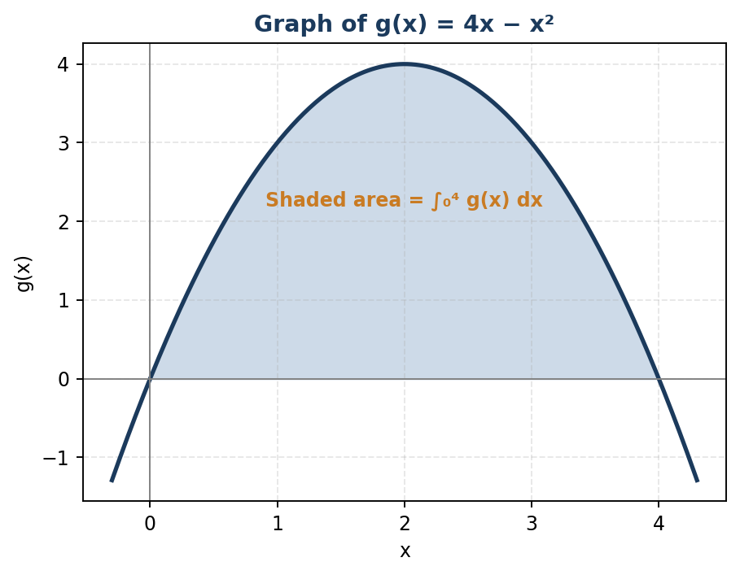
Figure: Graph of g(x) = 4x − x², with the area under the curve shaded
Using the Fundamental Theorem of Calculus, evaluate this definite integral (i.e. the shaded area).
(A) 8
(B) 9.33
(C) 10.67
(D) 12

Q.37 [2 marks] [NAT — enter numerical answer]
Evaluate: ∫₀¹ [x²/(1+x³)] dx. (Round off to two decimal places.)
Q.38 [2 marks] [NAT — enter numerical answer]
For the matrix A = [[5, 3], [1, 3]], find the LARGER of its two eigenvalues.
Q.39 [2 marks] [NAT — enter numerical answer]
The heights (cm) of 6 wheat plants are: 82, 85, 88, 90, 92, 95. Calculate the coefficient of variation (%), using the sample standard deviation (n−1 divisor). (Round off to two decimal places.)
Q.16 [1 mark] [MCQ]
The figure below shows the geometry of a disc plough: disc diameter D = 660 mm, disc angle α (the angle between the plane of the disc and the direction of travel) = 45°, and an operating depth d = 200 mm.
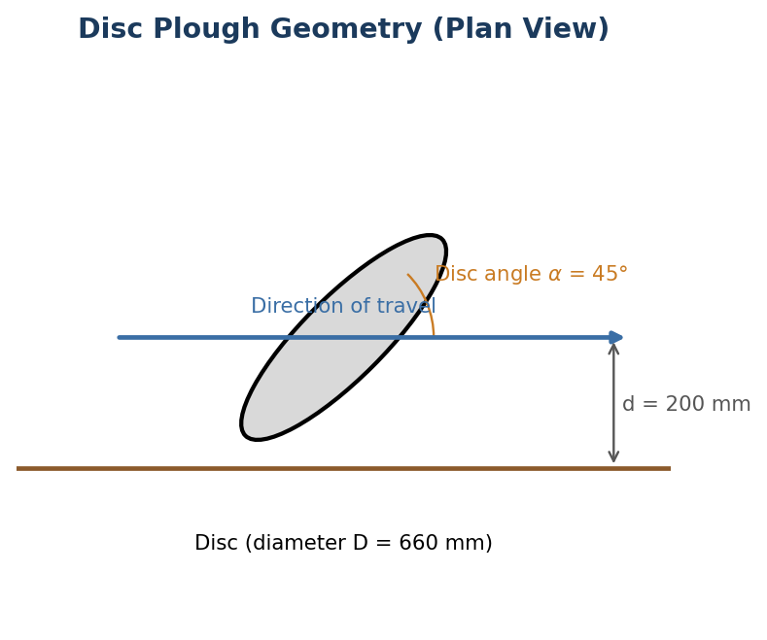
Figure: Disc plough geometry (plan view)
For proper penetration and cutting action, the disc angle α for a disc plough typically falls within the range:
(A) 10°–20°
(B) 25°–45°
(C) 50°–65°
(D) 70°–85°

Q.17 [1 mark] [MCQ]
In a reciprocating (sickle-bar) mower, the cutting action is achieved primarily by:
(A) A single reciprocating sickle blade shearing crop stems against fixed guards/ledger plates
(B) Impact of a high-speed rotating blade
(C) Combined suction and cutting action
(D) Pressing the crop stems between rollers

Q.18 [1 mark] [MCQ]
The figure below shows an open (non-crossed) flat belt drive connecting a driver pulley of diameter 300 mm to a driven pulley of diameter 500 mm, with a center distance of 1200 mm.
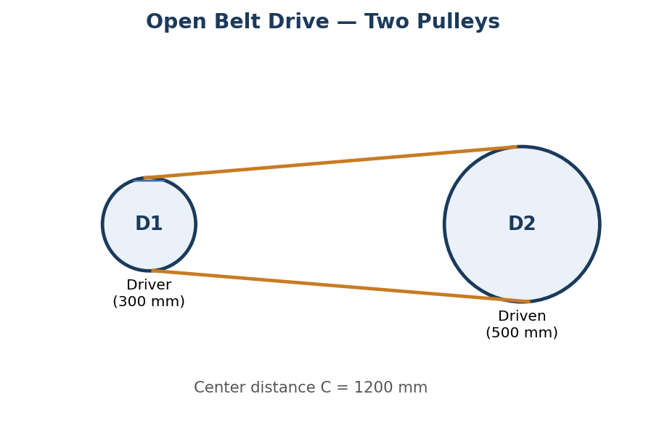
Figure: Open belt drive — two pulleys
For an open belt drive with pulleys of unequal diameter, the angle of wrap (contact angle) on the SMALLER pulley is:
(A) Exactly 180°
(B) Less than 180°
(C) Greater than 180°
(D) Exactly 90°

Q.40 [2 marks] [NAT — enter numerical answer]
A rotary tiller has 6 blades per flange, operates at a forward speed of 0.6 m/s and a rotor speed of 200 rpm. Calculate the pitch (distance travelled per blade strike) in mm. [Pitch = forward speed / (rotor speed in rev/s × number of blades per flange)] (Round off to two decimal places.)
Q.41 [2 marks] [NAT — enter numerical answer]
A forage harvester cuts a swath width of 1.8 m at a forward speed of 6 km/h, handling a crop with a yield of 40 t/ha (fresh weight). Calculate the fresh forage throughput rate (in t/h). (Round off to two decimal places.)
Q.42 [2 marks] [NAT — enter numerical answer]
An aerial spraying aircraft covers a swath width of 18 m at a flying speed of 160 km/h, applying a spray volume rate of 12 L/ha. Calculate the required nozzle discharge flow rate for the aircraft (in L/min). (Round off to two decimal places.)
Q.43 [2 marks] [NAT — enter numerical answer]
A tractor costs Rs 9,00,000, has a useful life of 10,000 hours, and a salvage value equal to 12% of its cost. Using straight-line depreciation, calculate the depreciation cost per hour of operation (in Rs). (Round off to two decimal places.)
Q.19 [1 mark] [MCQ]
A solar photovoltaic module has an efficiency of 18% under standard test conditions (1000 W/m² solar irradiance). What is the power output of a 2 m² module under these conditions?
(A) 200 W
(B) 280 W
(C) 360 W
(D) 400 W

Q.20 [1 mark] [MCQ]
Wheel slip of a tractor's drive wheel is defined as:
(A) The ratio of actual forward speed to theoretical (no-slip) speed
(B) The percentage reduction in actual travel distance compared to the theoretical (no-slip) distance the wheel would cover for the same number of wheel revolutions
(C) The angle between the wheel plane and the direction of travel
(D) The vertical deflection of the tyre under load

Q.21 [1 mark] [NAT — enter numerical answer]
An engine has 4 cylinders, each with a bore of 90 mm and a stroke of 100 mm. Calculate the total swept volume of the engine (in litres). (Round off to two decimal places.)
Q.22 [1 mark] [NAT — enter numerical answer]
As per standard ergonomic/occupational lighting guidelines, the recommended minimum illumination level (in lux) for general farm workshop tasks (e.g. routine machinery maintenance) is approximately ___ lux.
Q.44 [2 marks] [MCQ]
The figure below shows the typical relationship between tractive effort (pull) and wheel slip for a drive wheel operating on a given soil, along with the region of optimum tractive performance.
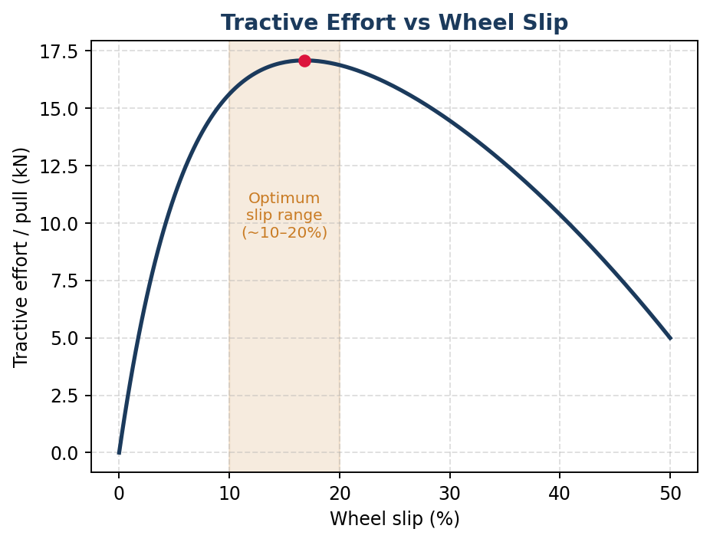
Figure: Tractive effort vs wheel slip
Based on the curve, as wheel slip increases substantially BEYOND the optimum range shown, the tractive effort (and correspondingly the tractive efficiency):
(A) Continues to increase indefinitely with further slip
(B) Remains constant regardless of slip
(C) Increases initially then decreases beyond the optimum range, since additional slip beyond that point wastes energy without a proportional gain in pull
(D) Is completely independent of the amount of wheel slip

Q.45 [2 marks] [NAT — enter numerical answer]
A biomass-gasifier-based dual-fuel genset uses producer gas with a methane content of 65% and a calorific value of methane of 35.5 MJ/m³. The genset consumes gas at 0.5 m³/min, and the overall gas-to-electrical conversion efficiency is 25%. Estimate the electrical power output (in kW). (Round off to two decimal places.)
Q.46 [2 marks] [NAT — enter numerical answer]
A tractor's theoretical (no-slip) forward speed, based on wheel rpm and rolling radius, is 8 km/h. Under load, the actual measured forward speed is 7.2 km/h. Calculate the wheel slip (in %). (Round off to two decimal places.)
Q.47 [2 marks] [NAT — enter numerical answer]
A tractor's differential distributes 40 kW total power equally between its two rear wheels when travelling straight (20 kW per wheel). One wheel experiences a 20% useful-power loss due to slip, while the other experiences only a 5% loss. Calculate the total power effectively converted to useful tractive work at the two wheels combined (in kW). [Useful power per wheel = power delivered × (1 − slip loss fraction)] (Round off to two decimal places.)
Q.48 [2 marks] [NAT — enter numerical answer]
A diesel engine has a mechanical efficiency of 85% and an indicated thermal efficiency of 42%. Calculate the brake thermal efficiency (in %). (Round off to two decimal places.)
Q.23 [1 mark] [MCQ]
Horton's infiltration equation describes:
(A) A constant rate of infiltration throughout a storm event
(B) The exponential decay of infiltration rate from an initial (higher) rate to a final, constant rate over the course of time
(C) The total infiltration volume, independent of time
(D) The relationship between infiltration and evaporation only

Q.24 [1 mark] [MCQ]
For a fluid in a container undergoing rigid-body rotation about a vertical axis, the free surface takes the shape of a:
(A) Flat horizontal plane
(B) Paraboloid of revolution
(C) Cone
(D) Sphere

Q.25 [1 mark] [NAT — enter numerical answer]
Using the Universal Soil Loss Equation A = R·K·LS·C·P, with R = 200, K = 0.35, LS = 1.2, C = 0.30 and P = 1.0, calculate the estimated annual soil loss A (in t/ha/yr). (Round off to two decimal places.)
Q.26 [1 mark] [NAT — enter numerical answer]
A soil sample has a dry unit weight of 16 kN/m³ and a specific gravity of solids Gs = 2.68. Taking the unit weight of water as 9.81 kN/m³, calculate the void ratio of the soil. (Round off to two decimal places.)
Q.49 [2 marks] [MCQ]
The figure below shows the variation of infiltration rate with time during a storm, following Horton's equation, with an initial infiltration rate f₀ = 60 mm/h and a final constant infiltration rate fc = 8 mm/h.
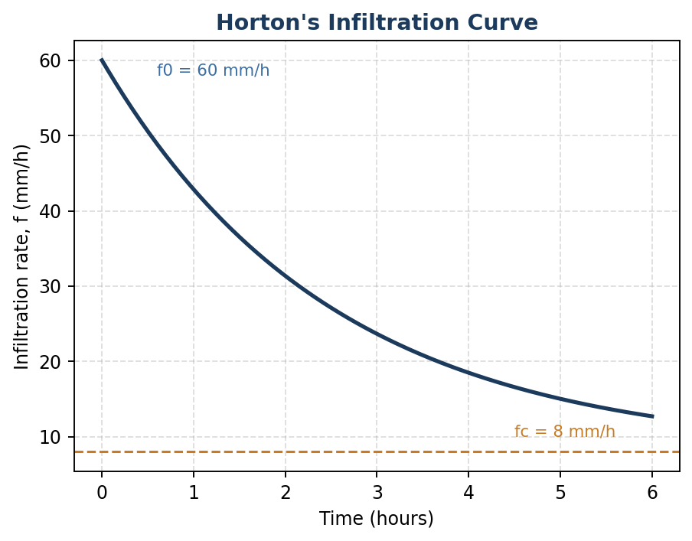
Figure: Horton's infiltration curve
From the graph, as time increases substantially during a prolonged storm, the infiltration rate approaches:
(A) Zero
(B) The initial rate f₀
(C) The final constant rate fc
(D) Infinity

Q.50 [2 marks] [MCQ]
The figure below shows a 90° V-notch (triangular) weir used to measure flow in a small irrigation channel, with head H measured above the vertex of the notch.
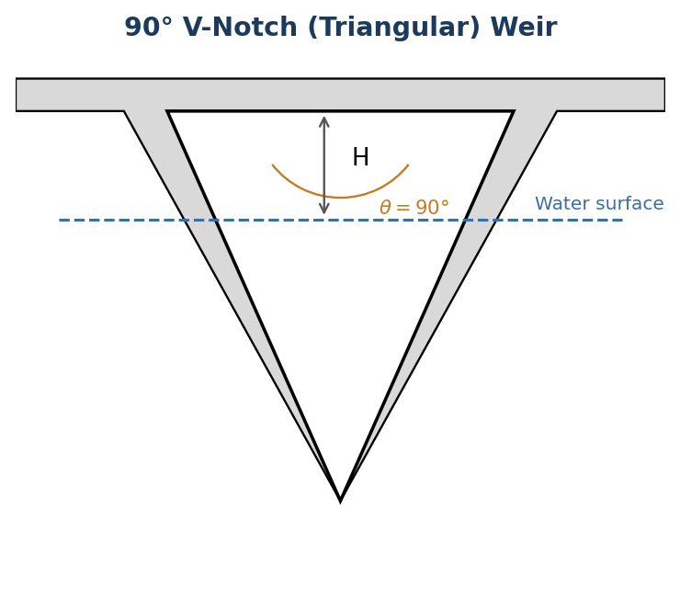
Figure: 90° V-notch (triangular) weir
For a V-notch weir, the discharge Q is related to the head H by which of the following proportionalities?
(A) Q ∝ H
(B) Q ∝ H^1.5
(C) Q ∝ H^2.5
(D) Q ∝ H^3

Q.51 [2 marks] [NAT — enter numerical answer]
Using Horton's equation f = fc + (f0−fc)e^(−kt), with f0 = 60 mm/h, fc = 8 mm/h and decay constant k = 0.4 per hour, calculate the infiltration rate at t = 2 hours (in mm/h). (Round off to two decimal places.)
Q.52 [2 marks] [NAT — enter numerical answer]
For the 90° V-notch weir shown earlier, with a coefficient of discharge Cd = 0.62, calculate the discharge (in L/s) for a head H = 0.25 m, using Q = Cd(8/15)√(2g)·tan(45°)·H^2.5. (Round off to two decimal places.)
Q.53 [2 marks] [NAT — enter numerical answer]
A field with USLE parameters R = 300, K = 0.32, LS = 2.2 and C = 0.18 has an annual soil loss above the tolerable limit T = 9.5 t/ha/yr. If a support practice (P factor) is introduced to bring the soil loss down to exactly this tolerable limit, calculate the required value of P. (Round off to two decimal places.)
Q.54 [2 marks] [NAT — enter numerical answer]
A closed traverse ABCD has interior angles measured at three of its four corners: A = 89°30', B = 91°15', C = 88°45'. Using the property that the sum of interior angles of a closed quadrilateral traverse equals 360°, calculate the interior angle at corner D (in decimal degrees). (Round off to two decimal places.)
Q.27 [1 mark] [MCQ]
The storage coefficient (storativity) of a CONFINED aquifer is typically of the order of:
(A) 0.05 to 0.30
(B) 0.00005 to 0.005
(C) 1.0 to 5.0
(D) 10 to 50

Q.28 [1 mark] [NAT — enter numerical answer]
A crop's total available water in the root zone is 120 mm. If irrigation is scheduled when 50% of the available water has been depleted, and the average daily crop evapotranspiration is 5 mm/day, calculate the irrigation interval (in days). (Round off to two decimal places.)
Q.55 [2 marks] [MSQ — one or more correct]
Which of the following statement(s) regarding drip (trickle) irrigation is/are CORRECT?
(A) Drip irrigation typically achieves higher water application efficiency than surface irrigation methods.
(B) Drip irrigation wets the entire soil surface uniformly, in the same manner as basin irrigation.
(C) Drip irrigation is particularly well suited to row crops, orchards, and widely-spaced plantations.
(D) Clogging of emitters due to physical, chemical, or biological factors is a significant operational concern in drip irrigation.

Q.56 [2 marks] [NAT — enter numerical answer]
The figure below shows a semi-log plot of drawdown (s) versus time (t) from a pumping test on a confined aquifer, analyzed using the Cooper–Jacob straight-line method. The plot shows a drawdown change of Δs = 0.55 m per log cycle of time, for a pumping rate Q = 1500 m³/day.
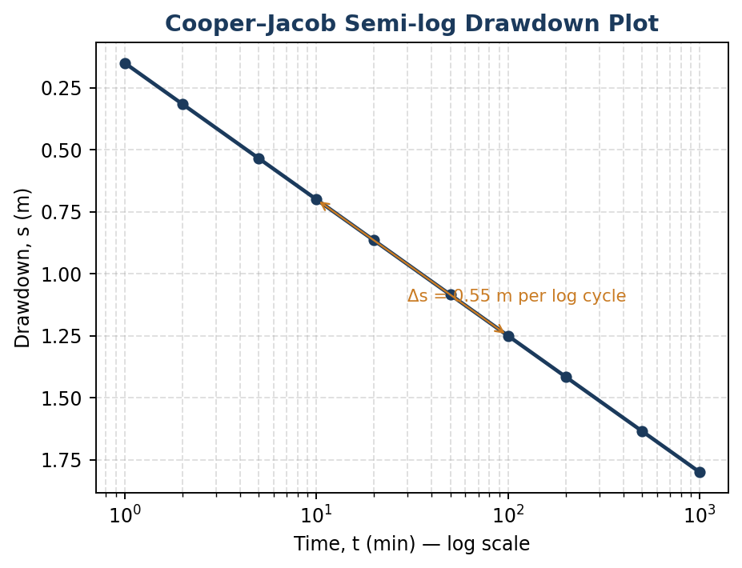
Figure: Cooper–Jacob semi-log drawdown plot
Using the Cooper–Jacob formula T = 2.303Q/(4πΔs), calculate the aquifer transmissivity T (in m²/day). (Round off to two decimal places.)
Q.57 [2 marks] [NAT — enter numerical answer]
For a subsurface tile drain resting directly on an impermeable barrier layer, the drainage coefficient may be estimated using q = 4Kh²/L², where K is the hydraulic conductivity, h is the height of the water table above the drain at the midpoint between drains, and L is the drain spacing. Given K = 0.45 m/day, L = 45 m and h = 1.0 m, calculate q (in mm/day). (Round off to two decimal places.)
Q.58 [2 marks] [NAT — enter numerical answer]
A confined aquifer has a transmissivity of 450 m²/day and an aquifer thickness of 18 m. Calculate its hydraulic conductivity K (in m/day). (Round off to two decimal places.)
Q.29 [1 mark] [MCQ]
The equilibrium moisture content (EMC) of a grain is defined as the moisture content at which:
(A) The grain has zero moisture
(B) The grain neither gains nor loses moisture when held in equilibrium with the surrounding air at a given temperature and relative humidity
(C) The grain is at its critical moisture content
(D) The grain reaches its maximum safe storage limit

Q.30 [1 mark] [MCQ]
In the extraction of oil from oilseeds, the mechanical method that uses a continuous, rotating screw-pressing action is called:
(A) Solvent extraction
(B) Expeller (screw) pressing
(C) Hydraulic (batch) pressing
(D) Centrifugal separation

Q.31 [1 mark] [NAT — enter numerical answer]
The angle of repose of a granular agricultural material is found to be 32°. If the material is heaped (in a cone) on a circular base of diameter 4 m, calculate the height of the resulting conical heap (in m). (Round off to two decimal places.)
Q.32 [1 mark] [NAT — enter numerical answer]
A hopper-bottom storage bin has a cylindrical section of diameter 3 m and height 5 m, plus a conical hopper section (same base diameter, height 1.2 m) below it. Calculate the total storage volume (in m³). (Round off to two decimal places.)
Q.33 [1 mark] [NAT — enter numerical answer]
200 kg of tapioca chips at 65% moisture content (wet basis) is dried to 12% moisture content (wet basis). Calculate the mass of water removed (in kg). (Round off to two decimal places.)
Q.59 [2 marks] [MSQ — one or more correct]
Which of the following statement(s) regarding oilseed processing is/are CORRECT?
(A) Solvent extraction (e.g. using hexane) generally achieves higher oil recovery from oilseed meal than mechanical expeller pressing alone.
(B) Pre-heating (cooking) of oilseeds before pressing helps rupture oil-bearing cells and reduce oil viscosity, improving expeller extraction efficiency.
(C) Degumming is a refining step that removes phospholipids and other gums from crude vegetable oil.
(D) The oil cake (meal) remaining after oil extraction has no nutritional value and is typically discarded as waste.

Q.60 [2 marks] [NAT — enter numerical answer]
The figure below shows a simplified psychrometric process diagram for a grain dryer: ambient air (state 1) at 28°C dry-bulb with a humidity ratio of 0.014 kg/kg dry air is heated at constant humidity ratio to state 2 at 60°C, then passes through the grain bed and exits as state 3 at 38°C with a humidity ratio of 0.024 kg/kg dry air.
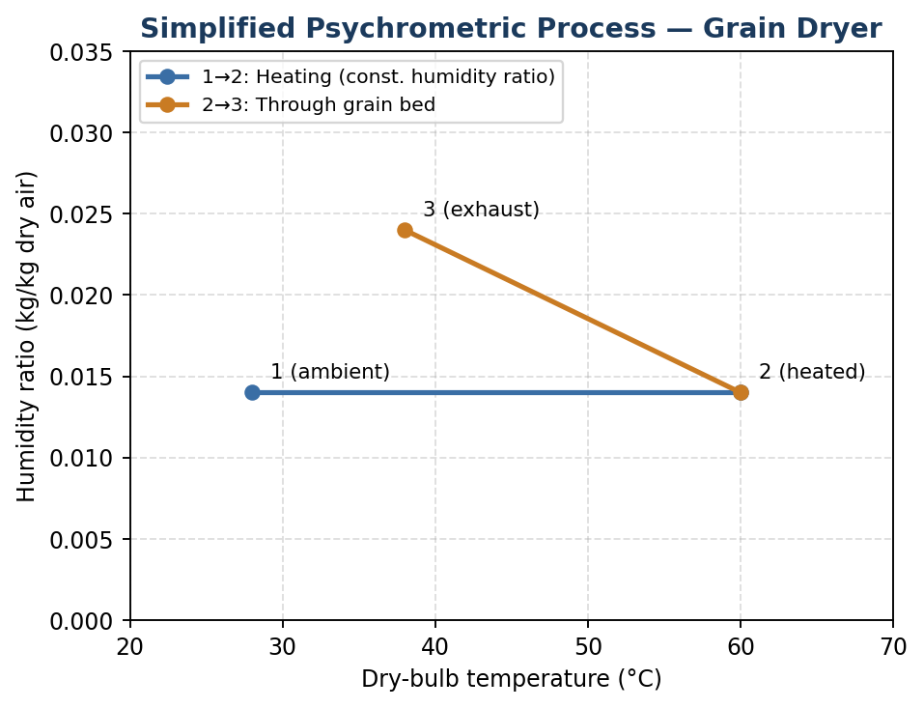
Figure: Simplified psychrometric process — grain dryer
Using the process shown, calculate the moisture picked up by the air per kg of dry air as it passes through the grain bed (state 2 to state 3), in kg moisture/kg dry air. (Round off to four decimal places.)
Q.61 [2 marks] [NAT — enter numerical answer]
A flat-bottom cylindrical bin of diameter 5 m is filled with maize to a height of 7 m. If the bulk density of maize is 740 kg/m³, calculate the total mass of maize stored (in tonnes). (Round off to two decimal places.)
Q.62 [2 marks] [NAT — enter numerical answer]
A cross-flow grain dryer processes grain with a constant dry-matter feed rate of 500 kg/h. Moisture content is reduced from 22% to 13% (both wet basis). Taking the latent heat of vaporization as 2260 kJ/kg, calculate the heat energy required for evaporation alone (in kW). (Round off to two decimal places.)
Q.34 [1 mark] [MCQ]
Which of the following preservation methods relies primarily on REDUCING THE WATER ACTIVITY (aw) of the food, rather than heat treatment, to inhibit microbial growth?
(A) Pasteurization
(B) Sterilization
(C) Salting/curing
(D) UHT processing

Q.35 [1 mark] [NAT — enter numerical answer]
In a plate heat exchanger, the overall heat transfer coefficient is 2500 W/(m²·K), the heat transfer area is 4 m², and the effective mean temperature difference is 12°C. Calculate the rate of heat transfer (in kW). (Round off to two decimal places.)
Q.63 [2 marks] [MSQ — one or more correct]
The figure below shows the temperature profile of the hot and cold fluid streams along the length of a counter-current (counter-flow) heat exchanger used for milk processing.
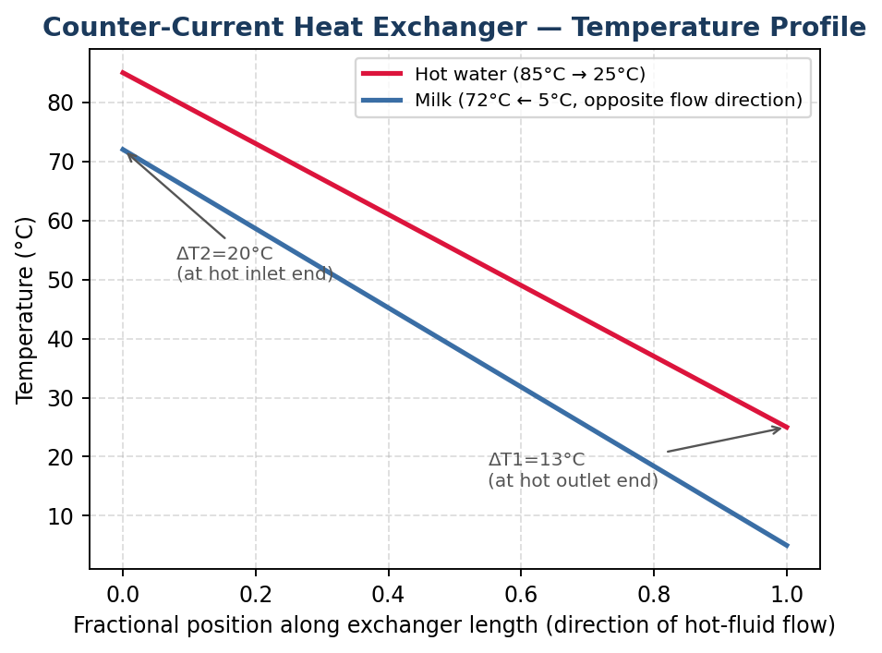
Figure: Counter-current heat exchanger — temperature profile
Based on the general behaviour of counter-current heat exchangers illustrated in such diagrams, which of the following statement(s) is/are CORRECT?
(A) In a counter-current arrangement, the temperature difference between the two streams can remain more uniform along the exchanger length compared to a parallel-flow arrangement.
(B) For the same inlet/outlet temperatures and flow rates, a counter-current exchanger generally requires a smaller heat transfer area than an equivalent parallel-flow exchanger.
(C) The hot fluid's local temperature must remain higher than the cold fluid's local temperature at every position along the exchanger, for heat to flow from hot to cold.
(D) The direction of fluid flow (counter-current vs parallel) has no effect on the log mean temperature difference (LMTD) of the exchanger.

Q.64 [2 marks] [MSQ — one or more correct]
Which of the following statement(s) about modified atmosphere packaging (MAP) and controlled atmosphere storage (CAS) of fresh produce is/are CORRECT?
(A) Both techniques typically involve reducing O2 levels and/or increasing CO2 levels relative to normal air composition, in order to slow the respiration rate of the produce.
(B) MAP relies on a fixed gas composition that is actively and continuously monitored and regulated throughout storage, in exactly the same way as CAS.
(C) Excessively low O2 levels (below a produce's tolerance limit) can induce anaerobic respiration, leading to off-flavours and tissue damage.
(D) CAS is generally applied in large bulk storage facilities (e.g. for apples), while MAP is more commonly applied at the individual package level.

Q.65 [2 marks] [NAT — enter numerical answer]
Referring to the counter-current heat exchanger temperature profile shown in the previous figure, milk enters at 5°C and leaves at 72°C, while hot water enters at 85°C and leaves at 25°C.

Figure: Counter-current heat exchanger — temperature profile (repeated for reference)
Using these terminal temperatures, calculate the Log Mean Temperature Difference (LMTD) for this counter-current exchanger (in °C). (Round off to two decimal places.)

Answer Key
Q.No. | Section | Sub-topic | Type | Marks | Answer
1 | GA | Quantitative Aptitude | MCQ | 1 | C
2 | GA | Quantitative Aptitude | MCQ | 1 | C
3 | GA | Verbal Aptitude | MCQ | 1 | A
4 | GA | Analytical Aptitude | MCQ | 1 | B
5 | GA | Data Interpretation | MCQ | 1 | D
6 | GA | Quantitative Aptitude | MCQ | 2 | C
7 | GA | Quantitative Aptitude | MCQ | 2 | C
8 | GA | Verbal Aptitude | MCQ | 2 | A
9 | GA | Analytical Aptitude | MCQ | 2 | D
10 | GA | Spatial Aptitude | MCQ | 2 | B
11 | S1 | Calculus | MCQ | 1 | B
12 | S1 | Vector Calculus (rotation-pool item, in place of part of Linear Algebra) | MCQ | 1 | A
13 | S1 | Linear Algebra | MCQ | 1 | A
14 | S1 | Differential Equations | MCQ | 1 | B
15 | S1 | Differential Equations | MCQ | 1 | A
36 | S1 | Calculus | MCQ | 2 | C
37 | S1 | Calculus | NAT | 2 | 0.20 to 0.25
38 | S1 | Linear Algebra | NAT | 2 | 5.80 to 6.20
39 | S1 | Probability and Statistics | NAT | 2 | 5.00 to 5.60
16 | S2 | Farm Machinery — soil tillage and forces on a tillage tool | MCQ | 1 | B
17 | S2 | Farm Machinery — harvesting, threshing, mowing and chaff cutting (rotation-pool item) | MCQ | 1 | A
18 | S2 | Machine Design — machine elements (gears, pulleys, chains, sprockets, belts, shafts) | MCQ | 1 | B
40 | S2 | Farm Machinery — soil tillage and forces on a tillage tool | NAT | 2 | 28.00 to 32.00
41 | S2 | Farm Machinery — harvesting, threshing, mowing and chaff cutting (rotation-pool item) | NAT | 2 | 42.00 to 44.50
42 | S2 | Farm Machinery — equipment for spraying | NAT | 2 | 56.00 to 59.50
43 | S2 | Cost analysis of implements and tractors | NAT | 2 | 77.00 to 81.50
19 | S3 | Sources of Power — solar | MCQ | 1 | C
20 | S3 | Tractors and Power Tillers — traction theory and mechanics of tractor chassis | MCQ | 1 | B
21 | S3 | Farm Power — engine components and I.C. engine systems | NAT | 1 | 2.45 to 2.65
22 | S3 | Human engineering, ergonomics and safety | NAT | 1 | 280 to 320
44 | S3 | Tractors and Power Tillers — traction theory and mechanics of tractor chassis | MCQ | 2 | C
45 | S3 | Sources of Power — biomass and bio-fuels | NAT | 2 | 46.50 to 49.50
46 | S3 | Tractors and Power Tillers — traction theory and mechanics of tractor chassis | NAT | 2 | 9.50 to 10.50
47 | S3 | Power transmission (clutch, gear box, differential, final drive, brakes) | NAT | 2 | 34.00 to 36.00
48 | S3 | Fuels, combustion and lubricants | NAT | 2 | 35.00 to 36.50
23 | S4 | Hydrology | MCQ | 1 | B
24 | S4 | Fluid Mechanics | MCQ | 1 | B
25 | S4 | Soil and Water Erosion | NAT | 1 | 24.50 to 26.00
26 | S4 | Soil Mechanics | NAT | 1 | 0.60 to 0.68
49 | S4 | Hydrology | MCQ | 2 | C
50 | S4 | Fluid Mechanics | MCQ | 2 | C
51 | S4 | Hydrology | NAT | 2 | 30.50 to 32.50
52 | S4 | Fluid Mechanics | NAT | 2 | 44.00 to 47.50
53 | S4 | Soil and Water Erosion | NAT | 2 | 0.23 to 0.27
54 | S4 | Surveying and Leveling | NAT | 2 | 90.30 to 90.70
27 | S5 | Groundwater Hydrology | MCQ | 1 | B
28 | S5 | Soil-Water-Plant Relationship | NAT | 1 | 11.50 to 12.50
55 | S5 | Irrigation Water Conveyance and Application Methods | MSQ | 2 | A, C, D
56 | S5 | Wells and Pumps | NAT | 2 | 495.00 to 505.00
57 | S5 | Agricultural Drainage | NAT | 2 | 0.82 to 0.96
58 | S5 | Groundwater Hydrology | NAT | 2 | 24.00 to 26.00
29 | S6 | Evaporation and Drying | MCQ | 1 | B
30 | S6 | Processing of Agricultural Produce (rotation-pool item) | MCQ | 1 | B
31 | S6 | Engineering properties of agricultural produce | NAT | 1 | 1.15 to 1.35
32 | S6 | Storage Systems | NAT | 1 | 37.50 to 38.80
33 | S6 | Evaporation and Drying | NAT | 1 | 118.50 to 122.00
59 | S6 | Processing of Agricultural Produce (rotation-pool item) | MSQ | 2 | A, B, C
60 | S6 | Evaporation and Drying | NAT | 2 | 0.0090 to 0.0110
61 | S6 | Storage Systems | NAT | 2 | 100.50 to 103.00
62 | S6 | Evaporation and Drying | NAT | 2 | 40.50 to 42.80
34 | S7 | Preservation of Food | MCQ | 1 | C
35 | S7 | Unit Operations in Dairy and Food Engineering (rotation-pool item) | NAT | 1 | 118.00 to 122.00
63 | S7 | Heat and Mass Transfer | MSQ | 2 | A, B, C
64 | S7 | Preservation of Food | MSQ | 2 | A, C, D
65 | S7 | Heat and Mass Transfer | NAT | 2 | 15.50 to 17.00

Detailed Solutions
Q.1 | General Aptitude | Quantitative Aptitude
Type: MCQ | Marks: 1
Question:
A cooperative pays compound interest at 10% per annum (compounded annually) on farmer deposits. If a farmer deposits Rs 50,000, what is the amount after 2 years?
(A) Rs 55,000
(B) Rs 58,000
(C) Rs 60,500
(D) Rs 63,000
Answer: C
Explanation:
Amount under compound interest, A = P(1+r)ⁿ = 50,000 × (1.10)² = 50,000 × 1.21 = Rs 60,500.
Why others are wrong: (A) 55,000 corresponds to simple interest for 1 year at 10%, not compound interest for 2 years. (B) 58,000 underestimates the compounding effect. (D) 63,000 overestimates it (e.g. using a higher effective rate or 3 years).
Q.2 | General Aptitude | Quantitative Aptitude
Type: MCQ | Marks: 1
Question:
The average yield of 5 plots is 42 quintals/ha. If a sixth plot with a yield of 60 quintals/ha is added to the group, what is the new average yield of all 6 plots?
(A) 43 quintals/ha
(B) 44 quintals/ha
(C) 45 quintals/ha
(D) 46 quintals/ha
Answer: C
Explanation:
Total yield of the original 5 plots = 5 × 42 = 210 quintals. Adding the sixth plot: new total = 210 + 60 = 270 quintals. New average = 270/6 = 45 quintals/ha.
Why others are wrong: (A) 43 and (B) 44 underestimate the effect of adding a higher-yielding plot. (D) 46 overestimates it — only 45 is consistent with the arithmetic.
Q.3 | General Aptitude | Verbal Aptitude
Type: MCQ | Marks: 1
Question:
Choose the pair that best expresses a relationship similar to that expressed by the pair: DROUGHT : IRRIGATION
(A) Disease : Vaccination
(B) Rain : Cloud
(C) Fire : Heat
(D) Wind : Storm
Answer: A
Explanation:
A drought is a problem/deficiency that is countered or mitigated by irrigation, a deliberate corrective measure. Analogously, a disease is a problem that is countered or prevented by vaccination, a deliberate corrective/preventive measure — both pairs express a problem-to-countermeasure relationship.
Why others are wrong: (B) Rain : Cloud describes a cause-effect/source relationship, not a problem-to-remedy relationship. (C) Fire : Heat describes a phenomenon and one of its inherent properties, not a problem-remedy pair. (D) Wind : Storm describes a component-to-larger-phenomenon relationship, again not a problem-remedy pair.
Q.4 | General Aptitude | Analytical Aptitude
Type: MCQ | Marks: 1
Question:
A is B's sister. C is A's husband. How is C related to B?
(A) Brother
(B) Brother-in-law
(C) Uncle
(D) Cousin
Answer: B
Explanation:
A is B's sister, and C is married to A. The husband of one's sister is one's brother-in-law. Therefore C is B's brother-in-law.
Why others are wrong: (A) Brother would require C to share parents with B, which is not stated — C is related to B only through marriage to A. (C) Uncle would require C to be a sibling of one of B's parents, which is not given. (D) Cousin would require C to share a grandparent with B, which is also not given.
Q.5 | General Aptitude | Data Interpretation
Type: MCQ | Marks: 1
Question:
The line graph below shows the retail diesel price (Rs/L) recorded at a village fuel pump over 6 consecutive months (January to June).

Figure: Retail diesel price (Rs/L), January–June
In which month was the PERCENTAGE increase in price over the previous month the highest?
(A) March
(B) April
(C) May
(D) June
Answer: D
Explanation:
Reading month-on-month percentage changes from the graph: Feb over Jan = (92−90)/90 = 2.22%; Mar over Feb = (95−92)/92 = 3.26%; Apr over Mar = (99−95)/95 = 4.21%; May over Apr = (101−99)/99 = 2.02%; Jun over May = (108−101)/101 = 6.93%. The highest percentage increase occurs in June.
Why others are wrong: March (3.26%), April (4.21%) and May (2.02%) all show smaller percentage increases than June (6.93%), even though the absolute price rise from April to May might look visually similar to other months on the graph — the question specifically asks for the percentage, not absolute, change.
Q.6 | General Aptitude | Quantitative Aptitude
Type: MCQ | Marks: 2
Question:
A dealer marks up the price of a rotavator by 40% above cost price, then offers a discount of 20% on the marked price. If the final selling price is Rs 33,600, find the cost price.
(A) Rs 28,000
(B) Rs 29,000
(C) Rs 30,000
(D) Rs 32,000
Answer: C
Explanation:
Marked price = CP × 1.40. Selling price after 20% discount = Marked price × 0.80 = CP × 1.40 × 0.80 = CP × 1.12. Given CP × 1.12 = 33,600, so CP = 33,600/1.12 = Rs 30,000.
Why others are wrong: (A) 28,000 and (B) 29,000 underestimate CP; multiplying either by 1.12 does not give 33,600. (D) 32,000 overestimates CP; 32,000 × 1.12 = 35,840 ≠ 33,600.
Q.7 | General Aptitude | Quantitative Aptitude
Type: MCQ | Marks: 2
Question:
A canal, if flowing continuously, can irrigate a field in 12 days. Due to a rotation schedule, water is supplied only on alternate days (supply on day 1, no supply on day 2, supply on day 3, and so on). How many total calendar days will it take to complete the irrigation?
(A) 21 days
(B) 22 days
(C) 23 days
(D) 24 days
Answer: C
Explanation:
The canal's rate is 1/12 of the field per full day of flow. Water flows only on odd-numbered calendar days (1, 3, 5, …). After 11 flow days (occurring by calendar day 21), 11/12 of the field is irrigated, leaving 1/12 remaining. The 12th flow day occurs on calendar day 23 (the next odd day after day 21), and exactly one more full day of flow (1/12) completes the job. So the work finishes at the end of calendar day 23.
Why others are wrong: (A) 21 days accounts for only 11 flow days (11/12 complete, not fully finished). (B) 22 days is a non-flow day under the schedule, so no additional progress is made on it beyond day 21's progress. (D) 24 days overshoots — the job is already complete by the end of day 23.
Q.8 | General Aptitude | Verbal Aptitude
Type: MCQ | Marks: 2
Question:
Consider the statement: "Every irrigation project sanctioned by the state receives central funding ONLY IF it meets the minimum command area criterion. Project X, a state-sanctioned project, has received central funding."
Which one of the following can be logically concluded from this statement alone?
(A) Project X meets the minimum command area criterion.
(B) Project X does not meet the minimum command area criterion.
(C) No conclusion regarding the criterion can be drawn for Project X.
(D) All state-sanctioned projects meet the criterion.
Answer: A
Explanation:
The phrase "receives funding ONLY IF it meets the criterion" translates logically to: (receives funding) → (meets criterion). Since Project X is stated to have received central funding, applying modus ponens directly gives that Project X meets the minimum command area criterion. This is a valid, direct inference (unlike statements phrased as "only if [condition], then [outcome]" used elsewhere, "P only if Q" always means P→Q).
Why others are wrong: (B) directly contradicts the valid modus ponens conclusion. (C) incorrectly claims insufficiency, when in fact the "only if" structure provides exactly the needed logical link. (D) over-generalizes from a single project (X) to a universal claim about "all" state-sanctioned projects, which the statement does not support.
Q.9 | General Aptitude | Analytical Aptitude
Type: MCQ | Marks: 2
Question:
Find the next term in the series: 3, 7, 15, 31, 63, ?
(A) 95
(B) 111
(C) 120
(D) 127
Answer: D
Explanation:
Each term follows the rule: next term = 2 × current term + 1. Check: 3×2+1=7; 7×2+1=15; 15×2+1=31; 31×2+1=63; 63×2+1=127.
Why others are wrong: 95, 111 and 120 do not satisfy the rule 2×63+1=127; they would require a different (incorrect) recurrence relation.
Q.10 | General Aptitude | Spatial Aptitude
Type: MCQ | Marks: 2
Question:
The figure below shows a sequence of four positions of an arrow-and-dot marker as it rotates by a FIXED angle at each successive step (0°, then rotated to 70°, then 140°, then 210°).

Figure: Sequence of marker rotations
If the pattern of rotation continues, through what additional angle (measured from the fourth position shown) must the marker further rotate to reach the fifth position in the sequence?
(A) 60°
(B) 70°
(C) 80°
(D) 90°
Answer: B
Explanation:
The angular positions shown are 0°, 70°, 140°, 210° — each successive position is obtained by adding a fixed increment of 70° to the previous one (70−0=70; 140−70=70; 210−140=70). Continuing this fixed increment, the fifth position requires a further rotation of 70° from the fourth position (210°), reaching 280°.
Why others are wrong: 60°, 80° and 90° do not match the consistent 70° increment observed between every consecutive pair of positions in the given sequence.
Q.11 | S1 — Engineering Mathematics | Calculus
Type: MCQ | Marks: 1
Question:
Find dy/dx for y = ln(x² + 1) at x = 1.
(A) 0.5
(B) 1
(C) 1.5
(D) 2
Answer: B
Explanation:
dy/dx = 2x/(x²+1) (chain rule). At x=1: dy/dx = 2(1)/(1²+1) = 2/2 = 1.
Why others are wrong: (A) 0.5 and (C) 1.5 would result from an arithmetic slip in evaluating 2/2. (D) 2 would result from omitting the denominator (x²+1) entirely.
Q.12 | S1 — Engineering Mathematics | Vector Calculus (rotation-pool item, in place of part of Linear Algebra)
Type: MCQ | Marks: 1
Question:
For the scalar field φ(x,y,z) = x²y + yz², find ∇φ at the point (1, 2, 1).
(A) (4, 2, 4)
(B) (2, 4, 2)
(C) (4, 4, 2)
(D) (2, 2, 4)
Answer: A
Explanation:
∇φ = (∂φ/∂x, ∂φ/∂y, ∂φ/∂z) = (2xy, x²+z², 2yz). At (1,2,1): ∂φ/∂x = 2(1)(2) = 4; ∂φ/∂y = 1²+1² = 2; ∂φ/∂z = 2(2)(1) = 4. So ∇φ = (4, 2, 4).
Why others are wrong: (B), (C) and (D) all correspond to permuting or miscalculating one or more of the three partial derivatives (e.g. swapping the x- and y-components, or mis-evaluating x²+z²).
Q.13 | S1 — Engineering Mathematics | Linear Algebra
Type: MCQ | Marks: 1
Question:
The matrix A = [[1, 2], [2, 4]] is singular. Why?
(A) Its rows are linearly dependent (Row 2 = 2 × Row 1), so det(A) = 0
(B) It is a symmetric matrix
(C) Its trace is zero
(D) It has complex eigenvalues
Answer: A
Explanation:
Row 2 = [2,4] = 2 × [1,2] = 2 × Row 1, so the rows are linearly dependent, making det(A) = (1)(4) − (2)(2) = 4−4 = 0. A matrix with zero determinant is singular (non-invertible).
Why others are wrong: (B) Symmetry alone does not imply singularity — many symmetric matrices are perfectly invertible. (C) The trace of A is 1+4=5, not zero, so this reasoning does not even apply here. (D) A is real and symmetric, so by the spectral theorem its eigenvalues are real, not complex — and even if it did have complex eigenvalues, that alone would not necessarily imply singularity.
Q.14 | S1 — Engineering Mathematics | Differential Equations
Type: MCQ | Marks: 1
Question:
Which of the following is the integrating factor for the linear ODE: dy/dx − y/x = x² (for x > 0)?
(A) x
(B) 1/x
(C) x²
(D) 1/x²
Answer: B
Explanation:
Writing the equation in standard form dy/dx + P(x)y = Q(x), here P(x) = −1/x. Integrating factor = e^(∫P dx) = e^(∫(−1/x)dx) = e^(−ln x) = 1/x.
Why others are wrong: (A) x would be the integrating factor if P(x) were +1/x, not −1/x. (C) x² and (D) 1/x² do not correspond to ∫(−1/x)dx = −ln x at all.
Q.15 | S1 — Engineering Mathematics | Differential Equations
Type: MCQ | Marks: 1
Question:
The general solution of the differential equation d²y/dx² + 9y = 0 is:
(A) C₁ cos 3x + C₂ sin 3x
(B) C₁ e^(3x) + C₂ e^(−3x)
(C) (C₁ + C₂x) e^(3x)
(D) C₁ e^(3x) + C₂x e^(3x)
Answer: A
Explanation:
The auxiliary equation is m² + 9 = 0, giving purely imaginary roots m = ±3i. For complex conjugate roots ±βi, the general solution takes the trigonometric form y = C₁cos(βx) + C₂sin(βx); here β=3, giving y = C₁cos3x + C₂sin3x.
Why others are wrong: (B) applies to real, distinct roots (not the case here, since the roots are imaginary). (C) and (D) apply to repeated real roots, which also does not match this equation's purely imaginary roots.
Q.36 | S1 — Engineering Mathematics | Calculus
Type: MCQ | Marks: 2
Question:
The figure below shows the graph of g(x) = 4x − x² over the interval [0,4], with the shaded region representing the definite integral ∫₀⁴ g(x) dx.

Figure: Graph of g(x) = 4x − x², with the area under the curve shaded
Using the Fundamental Theorem of Calculus, evaluate this definite integral (i.e. the shaded area).
(A) 8
(B) 9.33
(C) 10.67
(D) 12
Answer: C
Explanation:
∫(4x−x²)dx = 2x² − x³/3 + C. Evaluating from 0 to 4: [2(4)² − (4)³/3] − [0] = [32 − 64/3] = [96/3 − 64/3] = 32/3 = 10.67.
Why others are wrong: (A) 8 and (D) 12 do not match the correct antiderivative evaluation. (B) 9.33 (=28/3) would result from a small arithmetic slip in combining the two terms of the antiderivative.
Q.37 | S1 — Engineering Mathematics | Calculus
Type: NAT | Marks: 2
Question:
Evaluate: ∫₀¹ [x²/(1+x³)] dx. (Round off to two decimal places.)
Answer: 0.20 to 0.25
Explanation:
Substitute u = 1+x³, so du = 3x²dx, i.e. x²dx = du/3. When x=0, u=1; when x=1, u=2. The integral becomes (1/3)∫₁² du/u = (1/3)[ln u]₁² = (1/3)(ln2 − ln1) = (1/3)(0.6931) = 0.231 ≈ 0.23.
Q.38 | S1 — Engineering Mathematics | Linear Algebra
Type: NAT | Marks: 2
Question:
For the matrix A = [[5, 3], [1, 3]], find the LARGER of its two eigenvalues.
Answer: 5.80 to 6.20
Explanation:
Characteristic equation: (5−λ)(3−λ) − (3)(1) = 0 → 15 −5λ −3λ +λ² − 3 = 0 → λ² − 8λ + 12 = 0 → (λ−6)(λ−2) = 0. Eigenvalues are 6 and 2; the larger is 6.
Q.39 | S1 — Engineering Mathematics | Probability and Statistics
Type: NAT | Marks: 2
Question:
The heights (cm) of 6 wheat plants are: 82, 85, 88, 90, 92, 95. Calculate the coefficient of variation (%), using the sample standard deviation (n−1 divisor). (Round off to two decimal places.)
Answer: 5.00 to 5.60
Explanation:
Mean = (82+85+88+90+92+95)/6 = 532/6 = 88.667. Deviations: −6.667, −3.667, −0.667, 1.333, 3.333, 6.333. Squared deviations sum ≈ 111.33. Sample variance = 111.33/5 = 22.267. Sample SD = √22.267 = 4.718. Coefficient of variation = (SD/mean) × 100 = (4.718/88.667) × 100 = 5.32%.
Q.16 | S2 — Farm Machinery | Farm Machinery — soil tillage and forces on a tillage tool
Type: MCQ | Marks: 1
Question:
The figure below shows the geometry of a disc plough: disc diameter D = 660 mm, disc angle α (the angle between the plane of the disc and the direction of travel) = 45°, and an operating depth d = 200 mm.

Figure: Disc plough geometry (plan view)
For proper penetration and cutting action, the disc angle α for a disc plough typically falls within the range:
(A) 10°–20°
(B) 25°–45°
(C) 50°–65°
(D) 70°–85°
Answer: B
Explanation:
A disc angle in the range of approximately 25°–45° is standard practice for disc ploughs, balancing adequate penetration, soil inversion and draft requirements — the 45° angle shown in the figure lies at the upper end of this typical range.
Why others are wrong: (A) 10°–20° is too shallow an angle to achieve proper soil inversion and penetration. (C) 50°–65° and (D) 70°–85° are excessively steep angles that would produce poor penetration and excessive side-thrust rather than effective cutting/turning of the furrow slice.
Q.17 | S2 — Farm Machinery | Farm Machinery — harvesting, threshing, mowing and chaff cutting (rotation-pool item)
Type: MCQ | Marks: 1
Question:
In a reciprocating (sickle-bar) mower, the cutting action is achieved primarily by:
(A) A single reciprocating sickle blade shearing crop stems against fixed guards/ledger plates
(B) Impact of a high-speed rotating blade
(C) Combined suction and cutting action
(D) Pressing the crop stems between rollers
Answer: A
Explanation:
A sickle-bar mower cuts by a shearing action: the reciprocating (back-and-forth moving) sickle section moves across stationary guards (ledger plates), trapping and shearing crop stems between the moving blade edge and the fixed guard edge.
Why others are wrong: (B) High-speed rotary impact cutting describes rotary mowers/disc mowers, a different cutting mechanism. (C) Suction is not part of the mowing/cutting mechanism at all. (D) Pressing between rollers describes a crushing/conditioning action (as in mower-conditioners), not the primary cutting action itself.
Q.18 | S2 — Farm Machinery | Machine Design — machine elements (gears, pulleys, chains, sprockets, belts, shafts)
Type: MCQ | Marks: 1
Question:
The figure below shows an open (non-crossed) flat belt drive connecting a driver pulley of diameter 300 mm to a driven pulley of diameter 500 mm, with a center distance of 1200 mm.

Figure: Open belt drive — two pulleys
For an open belt drive with pulleys of unequal diameter, the angle of wrap (contact angle) on the SMALLER pulley is:
(A) Exactly 180°
(B) Less than 180°
(C) Greater than 180°
(D) Exactly 90°
Answer: B
Explanation:
In an open belt drive connecting unequal-diameter pulleys, the belt makes a smaller contact angle on the smaller pulley (less than 180°) and a correspondingly larger contact angle on the larger pulley (greater than 180°), because the belt must angle inward more sharply around the smaller pulley to reach the larger one.
Why others are wrong: (A) 180° would apply only if the two pulleys were of equal diameter. (C) Greater than 180° describes the wrap angle on the LARGER pulley, not the smaller one. (D) 90° has no general basis in belt-drive geometry for this configuration.
Q.40 | S2 — Farm Machinery | Farm Machinery — soil tillage and forces on a tillage tool
Type: NAT | Marks: 2
Question:
A rotary tiller has 6 blades per flange, operates at a forward speed of 0.6 m/s and a rotor speed of 200 rpm. Calculate the pitch (distance travelled per blade strike) in mm. [Pitch = forward speed / (rotor speed in rev/s × number of blades per flange)] (Round off to two decimal places.)
Answer: 28.00 to 32.00
Explanation:
Rotor speed = 200 rpm = 200/60 = 3.333 rev/s. Total blade strikes per second = 3.333 × 6 = 20 strikes/s. Pitch = forward speed / strikes per second = 0.6 m/s / 20 = 0.03 m = 30.00 mm.
Q.41 | S2 — Farm Machinery | Farm Machinery — harvesting, threshing, mowing and chaff cutting (rotation-pool item)
Type: NAT | Marks: 2
Question:
A forage harvester cuts a swath width of 1.8 m at a forward speed of 6 km/h, handling a crop with a yield of 40 t/ha (fresh weight). Calculate the fresh forage throughput rate (in t/h). (Round off to two decimal places.)
Answer: 42.00 to 44.50
Explanation:
Forward speed = 6 km/h = 6000 m/h. Area covered per hour = speed × width = 6000 × 1.8 = 10,800 m²/h = 1.08 ha/h. Throughput rate = area rate × yield = 1.08 × 40 = 43.20 t/h.
Q.42 | S2 — Farm Machinery | Farm Machinery — equipment for spraying
Type: NAT | Marks: 2
Question:
An aerial spraying aircraft covers a swath width of 18 m at a flying speed of 160 km/h, applying a spray volume rate of 12 L/ha. Calculate the required nozzle discharge flow rate for the aircraft (in L/min). (Round off to two decimal places.)
Answer: 56.00 to 59.50
Explanation:
Flying speed = 160 km/h = 1,60,000 m/h = 2666.67 m/min. Area covered per minute = 2666.67 × 18 = 48,000 m²/min = 4.8 ha/min. Required flow rate = area rate × application rate = 4.8 ha/min × 12 L/ha = 57.60 L/min.
Q.43 | S2 — Farm Machinery | Cost analysis of implements and tractors
Type: NAT | Marks: 2
Question:
A tractor costs Rs 9,00,000, has a useful life of 10,000 hours, and a salvage value equal to 12% of its cost. Using straight-line depreciation, calculate the depreciation cost per hour of operation (in Rs). (Round off to two decimal places.)
Answer: 77.00 to 81.50
Explanation:
Salvage value = 12% × 9,00,000 = Rs 1,08,000. Total depreciable amount = 9,00,000 − 1,08,000 = Rs 7,92,000. Depreciation cost per hour = 7,92,000/10,000 = Rs 79.20/hour.
Q.19 | S3 — Farm Power | Sources of Power — solar
Type: MCQ | Marks: 1
Question:
A solar photovoltaic module has an efficiency of 18% under standard test conditions (1000 W/m² solar irradiance). What is the power output of a 2 m² module under these conditions?
(A) 200 W
(B) 280 W
(C) 360 W
(D) 400 W
Answer: C
Explanation:
Power output = efficiency × irradiance × area = 0.18 × 1000 W/m² × 2 m² = 360 W.
Why others are wrong: (A) 200 W and (B) 280 W underestimate the output (e.g. using a lower efficiency or smaller area). (D) 400 W overestimates it (e.g. using a 20% efficiency instead of 18%).
Q.20 | S3 — Farm Power | Tractors and Power Tillers — traction theory and mechanics of tractor chassis
Type: MCQ | Marks: 1
Question:
Wheel slip of a tractor's drive wheel is defined as:
(A) The ratio of actual forward speed to theoretical (no-slip) speed
(B) The percentage reduction in actual travel distance compared to the theoretical (no-slip) distance the wheel would cover for the same number of wheel revolutions
(C) The angle between the wheel plane and the direction of travel
(D) The vertical deflection of the tyre under load
Answer: B
Explanation:
Wheel slip is defined as the percentage shortfall between the actual distance travelled and the theoretical distance the wheel would cover (based on its rotational speed and rolling radius, assuming no slip), for the same number of wheel revolutions — this shortfall arises because some wheel rotation is "wasted" overcoming soil shear rather than producing forward travel.
Why others are wrong: (A) describes a speed ratio, not the standard percentage-shortfall definition of slip. (C) describes wheel toe angle or crab angle, an unrelated steering/alignment concept. (D) describes tyre deflection, a structural/loading concept unrelated to slip.
Q.21 | S3 — Farm Power | Farm Power — engine components and I.C. engine systems
Type: NAT | Marks: 1
Question:
An engine has 4 cylinders, each with a bore of 90 mm and a stroke of 100 mm. Calculate the total swept volume of the engine (in litres). (Round off to two decimal places.)
Answer: 2.45 to 2.65
Explanation:
Swept volume of one cylinder = (π/4)d²L = (π/4)(0.09)²(0.10) = 0.7854 × 0.0081 × 0.10 = 0.0006362 m³ = 0.6362 L. Total swept volume for 4 cylinders = 4 × 0.6362 = 2.545 L.
Q.22 | S3 — Farm Power | Human engineering, ergonomics and safety
Type: NAT | Marks: 1
Question:
As per standard ergonomic/occupational lighting guidelines, the recommended minimum illumination level (in lux) for general farm workshop tasks (e.g. routine machinery maintenance) is approximately ___ lux.
Answer: 280 to 320
Explanation:
Standard occupational lighting guidance for general workshop maintenance tasks recommends a minimum illumination level of approximately 300 lux, sufficient for routine visual tasks without excessive eye strain.
Q.44 | S3 — Farm Power | Tractors and Power Tillers — traction theory and mechanics of tractor chassis
Type: MCQ | Marks: 2
Question:
The figure below shows the typical relationship between tractive effort (pull) and wheel slip for a drive wheel operating on a given soil, along with the region of optimum tractive performance.

Figure: Tractive effort vs wheel slip
Based on the curve, as wheel slip increases substantially BEYOND the optimum range shown, the tractive effort (and correspondingly the tractive efficiency):
(A) Continues to increase indefinitely with further slip
(B) Remains constant regardless of slip
(C) Increases initially then decreases beyond the optimum range, since additional slip beyond that point wastes energy without a proportional gain in pull
(D) Is completely independent of the amount of wheel slip
Answer: C
Explanation:
As shown in the graph, tractive effort rises with slip up to an optimum range (where the curve peaks), but beyond that range, further slip causes the tractive effort (and hence tractive efficiency, since more wheel rotation is being "wasted" without corresponding gain in pull) to decline, as the curve's downward trend past the peak illustrates.
Why others are wrong: (A) contradicts the graph, which clearly shows a decline after the peak, not indefinite increase. (B) and (D) both ignore the graph's clear dependence of tractive effort on slip, which rises and then falls rather than staying constant or being unrelated.
Q.45 | S3 — Farm Power | Sources of Power — biomass and bio-fuels
Type: NAT | Marks: 2
Question:
A biomass-gasifier-based dual-fuel genset uses producer gas with a methane content of 65% and a calorific value of methane of 35.5 MJ/m³. The genset consumes gas at 0.5 m³/min, and the overall gas-to-electrical conversion efficiency is 25%. Estimate the electrical power output (in kW). (Round off to two decimal places.)
Answer: 46.50 to 49.50
Explanation:
Calorific value of the producer gas ≈ 0.65 × 35.5 = 23.075 MJ/m³ (assuming the non-methane fraction contributes negligibly). Thermal energy input rate = 0.5 m³/min × 23.075 MJ/m³ = 11.5375 MJ/min = 11,537.5 kJ / 60 s = 192.29 kW (thermal). Electrical power output = 192.29 × 0.25 = 48.07 kW.
Q.46 | S3 — Farm Power | Tractors and Power Tillers — traction theory and mechanics of tractor chassis
Type: NAT | Marks: 2
Question:
A tractor's theoretical (no-slip) forward speed, based on wheel rpm and rolling radius, is 8 km/h. Under load, the actual measured forward speed is 7.2 km/h. Calculate the wheel slip (in %). (Round off to two decimal places.)
Answer: 9.50 to 10.50
Explanation:
Wheel slip (%) = [(theoretical speed − actual speed)/theoretical speed] × 100 = [(8 − 7.2)/8] × 100 = (0.8/8) × 100 = 10.00%.
Q.47 | S3 — Farm Power | Power transmission (clutch, gear box, differential, final drive, brakes)
Type: NAT | Marks: 2
Question:
A tractor's differential distributes 40 kW total power equally between its two rear wheels when travelling straight (20 kW per wheel). One wheel experiences a 20% useful-power loss due to slip, while the other experiences only a 5% loss. Calculate the total power effectively converted to useful tractive work at the two wheels combined (in kW). [Useful power per wheel = power delivered × (1 − slip loss fraction)] (Round off to two decimal places.)
Answer: 34.00 to 36.00
Explanation:
Wheel 1 (20% loss): useful power = 20 × (1 − 0.20) = 16 kW. Wheel 2 (5% loss): useful power = 20 × (1 − 0.05) = 19 kW. Total useful tractive power = 16 + 19 = 35.00 kW.
Q.48 | S3 — Farm Power | Fuels, combustion and lubricants
Type: NAT | Marks: 2
Question:
A diesel engine has a mechanical efficiency of 85% and an indicated thermal efficiency of 42%. Calculate the brake thermal efficiency (in %). (Round off to two decimal places.)
Answer: 35.00 to 36.50
Explanation:
Brake thermal efficiency = Indicated thermal efficiency × Mechanical efficiency = 0.42 × 0.85 = 0.357 = 35.70%.
Q.23 | S4 — Soil & Water Conservation Engineering | Hydrology
Type: MCQ | Marks: 1
Question:
Horton's infiltration equation describes:
(A) A constant rate of infiltration throughout a storm event
(B) The exponential decay of infiltration rate from an initial (higher) rate to a final, constant rate over the course of time
(C) The total infiltration volume, independent of time
(D) The relationship between infiltration and evaporation only
Answer: B
Explanation:
Horton's equation, f = fc + (f0−fc)e^(−kt), models infiltration capacity as decaying exponentially from an initial rate f0 (typically high, at the onset of a storm on relatively dry soil) towards a final, essentially constant rate fc (as the soil becomes progressively saturated), with k being the decay constant.
Why others are wrong: (A) describes a fundamentally different, non-decaying (constant-rate) model, not Horton's equation. (C) describes only the cumulative infiltration volume, a related but distinct quantity from the infiltration rate, which is what Horton's equation directly models. (D) is unrelated — Horton's equation involves only infiltration rate and time, with no explicit evaporation term.
Q.24 | S4 — Soil & Water Conservation Engineering | Fluid Mechanics
Type: MCQ | Marks: 1
Question:
For a fluid in a container undergoing rigid-body rotation about a vertical axis, the free surface takes the shape of a:
(A) Flat horizontal plane
(B) Paraboloid of revolution
(C) Cone
(D) Sphere
Answer: B
Explanation:
For rigid-body rotation, the free surface adopts a shape where the pressure is constant (atmospheric), and analysis of the radial and vertical pressure variation under centrifugal and gravitational effects shows that this surface is a paraboloid of revolution, with the surface elevation increasing as the square of the radial distance from the axis.
Why others are wrong: (A) A flat plane would apply only to a fluid at rest (no rotation). (C) A cone would imply a linear (not quadratic) relationship between elevation and radius, which does not match the governing pressure-balance equations. (D) A sphere is not the shape predicted by the balance of centrifugal and gravitational forces on the free surface.
Q.25 | S4 — Soil & Water Conservation Engineering | Soil and Water Erosion
Type: NAT | Marks: 1
Question:
Using the Universal Soil Loss Equation A = R·K·LS·C·P, with R = 200, K = 0.35, LS = 1.2, C = 0.30 and P = 1.0, calculate the estimated annual soil loss A (in t/ha/yr). (Round off to two decimal places.)
Answer: 24.50 to 26.00
Explanation:
A = R×K×LS×C×P = 200 × 0.35 × 1.2 × 0.30 × 1.0. Step by step: 200×0.35=70; 70×1.2=84; 84×0.30=25.20.
Q.26 | S4 — Soil & Water Conservation Engineering | Soil Mechanics
Type: NAT | Marks: 1
Question:
A soil sample has a dry unit weight of 16 kN/m³ and a specific gravity of solids Gs = 2.68. Taking the unit weight of water as 9.81 kN/m³, calculate the void ratio of the soil. (Round off to two decimal places.)
Answer: 0.60 to 0.68
Explanation:
Dry unit weight, γd = Gs·γw/(1+e). So 16 = (2.68 × 9.81)/(1+e) = 26.29/(1+e), giving (1+e) = 26.29/16 = 1.643, so e = 0.643.
Q.49 | S4 — Soil & Water Conservation Engineering | Hydrology
Type: MCQ | Marks: 2
Question:
The figure below shows the variation of infiltration rate with time during a storm, following Horton's equation, with an initial infiltration rate f₀ = 60 mm/h and a final constant infiltration rate fc = 8 mm/h.

Figure: Horton's infiltration curve
From the graph, as time increases substantially during a prolonged storm, the infiltration rate approaches:
(A) Zero
(B) The initial rate f₀
(C) The final constant rate fc
(D) Infinity
Answer: C
Explanation:
As shown in the graph, the curve decays exponentially from f₀ = 60 mm/h and asymptotically flattens out, approaching the final constant infiltration rate fc = 8 mm/h as time becomes large — this is the defining behaviour of Horton's exponential-decay model.
Why others are wrong: (A) Zero is not the asymptotic value shown; the curve levels off at fc = 8 mm/h, not 0. (B) The initial rate f₀ applies only at the very start (t=0), not as time increases. (D) Infinity is inconsistent with the graph, which shows the rate decreasing and stabilizing, never increasing without bound.
Q.50 | S4 — Soil & Water Conservation Engineering | Fluid Mechanics
Type: MCQ | Marks: 2
Question:
The figure below shows a 90° V-notch (triangular) weir used to measure flow in a small irrigation channel, with head H measured above the vertex of the notch.

Figure: 90° V-notch (triangular) weir
For a V-notch weir, the discharge Q is related to the head H by which of the following proportionalities?
(A) Q ∝ H
(B) Q ∝ H^1.5
(C) Q ∝ H^2.5
(D) Q ∝ H^3
Answer: C
Explanation:
The standard theoretical discharge formula for a V-notch (triangular) weir is Q = Cd(8/15)√(2g)·tan(θ/2)·H^2.5, derived by integrating the elemental strip discharge across the triangular opening — giving discharge proportional to H raised to the power 2.5.
Why others are wrong: (A) Q∝H and (B) Q∝H^1.5 are the relationships associated with (respectively) an orifice under a small constant head approximation and a rectangular (not triangular) sharp-crested weir. (D) Q∝H^3 does not correspond to the correct exponent derived from the V-notch geometry.
Q.51 | S4 — Soil & Water Conservation Engineering | Hydrology
Type: NAT | Marks: 2
Question:
Using Horton's equation f = fc + (f0−fc)e^(−kt), with f0 = 60 mm/h, fc = 8 mm/h and decay constant k = 0.4 per hour, calculate the infiltration rate at t = 2 hours (in mm/h). (Round off to two decimal places.)
Answer: 30.50 to 32.50
Explanation:
f = 8 + (60−8)e^(−0.4×2) = 8 + 52 × e^(−0.8) = 8 + 52 × 0.4493 = 8 + 23.36 = 31.36 mm/h.
Q.52 | S4 — Soil & Water Conservation Engineering | Fluid Mechanics
Type: NAT | Marks: 2
Question:
For the 90° V-notch weir shown earlier, with a coefficient of discharge Cd = 0.62, calculate the discharge (in L/s) for a head H = 0.25 m, using Q = Cd(8/15)√(2g)·tan(45°)·H^2.5. (Round off to two decimal places.)
Answer: 44.00 to 47.50
Explanation:
√(2g) = √19.62 = 4.429. tan(45°) = 1. H^2.5 = (0.25)^2.5 = 0.0625 × √0.25 = 0.0625 × 0.5 = 0.03125. Q = 0.62 × (8/15) × 4.429 × 1 × 0.03125 = 0.62 × 0.5333 × 4.429 × 0.03125 = 0.04578 m³/s = 45.78 L/s.
Q.53 | S4 — Soil & Water Conservation Engineering | Soil and Water Erosion
Type: NAT | Marks: 2
Question:
A field with USLE parameters R = 300, K = 0.32, LS = 2.2 and C = 0.18 has an annual soil loss above the tolerable limit T = 9.5 t/ha/yr. If a support practice (P factor) is introduced to bring the soil loss down to exactly this tolerable limit, calculate the required value of P. (Round off to two decimal places.)
Answer: 0.23 to 0.27
Explanation:
Soil loss without the support practice, A₀ = R×K×LS×C = 300 × 0.32 × 2.2 × 0.18. Step by step: 300×0.32=96; 96×2.2=211.2; 211.2×0.18=38.016 t/ha/yr. Required P = T/A₀ = 9.5/38.016 = 0.2499 ≈ 0.25.
Q.54 | S4 — Soil & Water Conservation Engineering | Surveying and Leveling
Type: NAT | Marks: 2
Question:
A closed traverse ABCD has interior angles measured at three of its four corners: A = 89°30', B = 91°15', C = 88°45'. Using the property that the sum of interior angles of a closed quadrilateral traverse equals 360°, calculate the interior angle at corner D (in decimal degrees). (Round off to two decimal places.)
Answer: 90.30 to 90.70
Explanation:
Converting to decimal degrees: A = 89.50°, B = 91.25°, C = 88.75°. Sum of known angles = 89.50+91.25+88.75 = 269.50°. Since the four interior angles of a closed quadrilateral traverse must sum to 360°: D = 360 − 269.50 = 90.50°.
Q.27 | S5 — Irrigation & Drainage Engineering | Groundwater Hydrology
Type: MCQ | Marks: 1
Question:
The storage coefficient (storativity) of a CONFINED aquifer is typically of the order of:
(A) 0.05 to 0.30
(B) 0.00005 to 0.005
(C) 1.0 to 5.0
(D) 10 to 50
Answer: B
Explanation:
Confined aquifers release water primarily through the elastic compressibility of the aquifer skeleton and the slight compressibility of water itself, resulting in a storage coefficient that is very small, typically in the range of about 0.00005 to 0.005 — orders of magnitude smaller than the specific yield of an unconfined aquifer.
Why others are wrong: (A) 0.05 to 0.30 is more representative of the specific yield of an UNCONFINED aquifer (governed by gravity drainage of pores), not the storage coefficient of a confined aquifer. (C) and (D) are far too large to be physically meaningful storage coefficients for any real aquifer, confined or otherwise.
Q.28 | S5 — Irrigation & Drainage Engineering | Soil-Water-Plant Relationship
Type: NAT | Marks: 1
Question:
A crop's total available water in the root zone is 120 mm. If irrigation is scheduled when 50% of the available water has been depleted, and the average daily crop evapotranspiration is 5 mm/day, calculate the irrigation interval (in days). (Round off to two decimal places.)
Answer: 11.50 to 12.50
Explanation:
Allowable depletion = 50% × 120 mm = 60 mm. Irrigation interval = allowable depletion / daily ET = 60/5 = 12.00 days.
Q.55 | S5 — Irrigation & Drainage Engineering | Irrigation Water Conveyance and Application Methods
Type: MSQ | Marks: 2
Question:
Which of the following statement(s) regarding drip (trickle) irrigation is/are CORRECT?
(A) Drip irrigation typically achieves higher water application efficiency than surface irrigation methods.
(B) Drip irrigation wets the entire soil surface uniformly, in the same manner as basin irrigation.
(C) Drip irrigation is particularly well suited to row crops, orchards, and widely-spaced plantations.
(D) Clogging of emitters due to physical, chemical, or biological factors is a significant operational concern in drip irrigation.
Answer: A, C, D
Explanation:
(A) Correct — drip irrigation delivers water directly and slowly to the root zone, minimizing conveyance, evaporation and deep-percolation losses, generally giving higher application efficiency than surface methods. (C) Correct — the point/localized wetting pattern of drip irrigation is particularly well matched to individually-spaced plants such as row crops, orchard trees and vineyards. (D) Correct — emitter clogging (from suspended solids, chemical precipitates, or biological growth/slime) is indeed a well-documented and significant maintenance concern in drip systems.
(B) is incorrect — drip irrigation deliberately wets only a limited zone of soil near each emitter (partial wetting), fundamentally different from the full-surface flooding characteristic of basin irrigation.
Q.56 | S5 — Irrigation & Drainage Engineering | Wells and Pumps
Type: NAT | Marks: 2
Question:
The figure below shows a semi-log plot of drawdown (s) versus time (t) from a pumping test on a confined aquifer, analyzed using the Cooper–Jacob straight-line method. The plot shows a drawdown change of Δs = 0.55 m per log cycle of time, for a pumping rate Q = 1500 m³/day.

Figure: Cooper–Jacob semi-log drawdown plot
Using the Cooper–Jacob formula T = 2.303Q/(4πΔs), calculate the aquifer transmissivity T (in m²/day). (Round off to two decimal places.)
Answer: 495.00 to 505.00
Explanation:
T = 2.303 × Q / (4π × Δs) = (2.303 × 1500) / (4π × 0.55) = 3454.5 / 6.9115 = 499.72 m²/day.
Q.57 | S5 — Irrigation & Drainage Engineering | Agricultural Drainage
Type: NAT | Marks: 2
Question:
For a subsurface tile drain resting directly on an impermeable barrier layer, the drainage coefficient may be estimated using q = 4Kh²/L², where K is the hydraulic conductivity, h is the height of the water table above the drain at the midpoint between drains, and L is the drain spacing. Given K = 0.45 m/day, L = 45 m and h = 1.0 m, calculate q (in mm/day). (Round off to two decimal places.)
Answer: 0.82 to 0.96
Explanation:
q = 4Kh²/L² = 4 × 0.45 × (1.0)² / (45)² = 1.8/2025 = 0.000889 m/day = 0.89 mm/day.
Q.58 | S5 — Irrigation & Drainage Engineering | Groundwater Hydrology
Type: NAT | Marks: 2
Question:
A confined aquifer has a transmissivity of 450 m²/day and an aquifer thickness of 18 m. Calculate its hydraulic conductivity K (in m/day). (Round off to two decimal places.)
Answer: 24.00 to 26.00
Explanation:
Transmissivity, T = K × aquifer thickness, so K = T/thickness = 450/18 = 25.00 m/day.
Q.29 | S6 — Agricultural Process Engineering | Evaporation and Drying
Type: MCQ | Marks: 1
Question:
The equilibrium moisture content (EMC) of a grain is defined as the moisture content at which:
(A) The grain has zero moisture
(B) The grain neither gains nor loses moisture when held in equilibrium with the surrounding air at a given temperature and relative humidity
(C) The grain is at its critical moisture content
(D) The grain reaches its maximum safe storage limit
Answer: B
Explanation:
The equilibrium moisture content is the specific moisture content a hygroscopic material (like grain) eventually attains when exposed indefinitely to air at a given constant temperature and relative humidity, at which point there is no net moisture exchange between the grain and the surrounding air.
Why others are wrong: (A) Zero moisture is an extreme, not generally the equilibrium value under real ambient conditions. (C) Critical moisture content is a distinct drying-curve concept (constant-rate to falling-rate transition), not related to air-equilibrium. (D) Safe storage moisture content is a storage-stability criterion, a different concept from the air-equilibrium condition defining EMC.
Q.30 | S6 — Agricultural Process Engineering | Processing of Agricultural Produce (rotation-pool item)
Type: MCQ | Marks: 1
Question:
In the extraction of oil from oilseeds, the mechanical method that uses a continuous, rotating screw-pressing action is called:
(A) Solvent extraction
(B) Expeller (screw) pressing
(C) Hydraulic (batch) pressing
(D) Centrifugal separation
Answer: B
Explanation:
Expeller (screw) pressing uses a continuously rotating screw (worm shaft) within a barrel to progressively compress oilseed material, squeezing out oil under continuously increasing pressure as the seed cake is conveyed along the screw.
Why others are wrong: (A) Solvent extraction uses a chemical solvent (e.g. hexane) to dissolve out the oil, not mechanical pressing. (C) Hydraulic (batch) pressing uses static hydraulic pressure applied in discrete batches, not continuous screw rotation. (D) Centrifugal separation separates substances (e.g. cream from milk, or oil from water) by density difference under centrifugal force, not by pressing oilseeds.
Q.31 | S6 — Agricultural Process Engineering | Engineering properties of agricultural produce
Type: NAT | Marks: 1
Question:
The angle of repose of a granular agricultural material is found to be 32°. If the material is heaped (in a cone) on a circular base of diameter 4 m, calculate the height of the resulting conical heap (in m). (Round off to two decimal places.)
Answer: 1.15 to 1.35
Explanation:
For a conical heap, tan(angle of repose) = height/radius. Radius = 4/2 = 2 m. Height = radius × tan(32°) = 2 × 0.6249 = 1.25 m.
Q.32 | S6 — Agricultural Process Engineering | Storage Systems
Type: NAT | Marks: 1
Question:
A hopper-bottom storage bin has a cylindrical section of diameter 3 m and height 5 m, plus a conical hopper section (same base diameter, height 1.2 m) below it. Calculate the total storage volume (in m³). (Round off to two decimal places.)
Answer: 37.50 to 38.80
Explanation:
Cylinder volume = (π/4)d²h = (π/4)(3)²(5) = 0.7854×9×5 = 35.343 m³. Cone volume = (1/3)(π/4)d²h = (1/3)(0.7854)(9)(1.2) = (1/3)(8.482) = 2.827 m³. Total volume = 35.343 + 2.827 = 38.17 m³.
Q.33 | S6 — Agricultural Process Engineering | Evaporation and Drying
Type: NAT | Marks: 1
Question:
200 kg of tapioca chips at 65% moisture content (wet basis) is dried to 12% moisture content (wet basis). Calculate the mass of water removed (in kg). (Round off to two decimal places.)
Answer: 118.50 to 122.00
Explanation:
Mass of dry matter (unchanged during drying) = 200 × (1−0.65) = 70 kg. Final total mass at 12% m.c.: dry matter is 88% of final mass, so final mass = 70/0.88 = 79.545 kg. Water removed = initial mass − final mass = 200 − 79.545 = 120.45 kg.
Q.59 | S6 — Agricultural Process Engineering | Processing of Agricultural Produce (rotation-pool item)
Type: MSQ | Marks: 2
Question:
Which of the following statement(s) regarding oilseed processing is/are CORRECT?
(A) Solvent extraction (e.g. using hexane) generally achieves higher oil recovery from oilseed meal than mechanical expeller pressing alone.
(B) Pre-heating (cooking) of oilseeds before pressing helps rupture oil-bearing cells and reduce oil viscosity, improving expeller extraction efficiency.
(C) Degumming is a refining step that removes phospholipids and other gums from crude vegetable oil.
(D) The oil cake (meal) remaining after oil extraction has no nutritional value and is typically discarded as waste.
Answer: A, B, C
Explanation:
(A) Correct — solvent extraction can achieve much more complete oil removal from the residual meal (often leaving only 1% or less residual oil) compared to mechanical pressing alone (which typically leaves several percent residual oil). (B) Correct — pre-heating/cooking softens cell walls and reduces oil viscosity, both of which improve mechanical oil expression during pressing. (C) Correct — degumming precisely targets phospholipids and other gum-forming impurities as an early step in oil refining.
(D) is incorrect — oil cake/meal is a valuable, protein-rich by-product that is widely used as animal feed, not discarded as waste.
Q.60 | S6 — Agricultural Process Engineering | Evaporation and Drying
Type: NAT | Marks: 2
Question:
The figure below shows a simplified psychrometric process diagram for a grain dryer: ambient air (state 1) at 28°C dry-bulb with a humidity ratio of 0.014 kg/kg dry air is heated at constant humidity ratio to state 2 at 60°C, then passes through the grain bed and exits as state 3 at 38°C with a humidity ratio of 0.024 kg/kg dry air.

Figure: Simplified psychrometric process — grain dryer
Using the process shown, calculate the moisture picked up by the air per kg of dry air as it passes through the grain bed (state 2 to state 3), in kg moisture/kg dry air. (Round off to four decimal places.)
Answer: 0.0090 to 0.0110
Explanation:
Moisture pickup, Δw = w₃ − w₂. Since heating (1→2) occurs at constant humidity ratio, w₂ = w₁ = 0.014 kg/kg dry air (as shown in the figure). So Δw = 0.024 − 0.014 = 0.0100 kg moisture per kg dry air.
Q.61 | S6 — Agricultural Process Engineering | Storage Systems
Type: NAT | Marks: 2
Question:
A flat-bottom cylindrical bin of diameter 5 m is filled with maize to a height of 7 m. If the bulk density of maize is 740 kg/m³, calculate the total mass of maize stored (in tonnes). (Round off to two decimal places.)
Answer: 100.50 to 103.00
Explanation:
Volume = (π/4)d²h = (π/4)(5)²(7) = 0.7854×25×7 = 137.44 m³. Mass = volume × bulk density = 137.44 × 740 = 1,01,706 kg = 101.71 t.
Q.62 | S6 — Agricultural Process Engineering | Evaporation and Drying
Type: NAT | Marks: 2
Question:
A cross-flow grain dryer processes grain with a constant dry-matter feed rate of 500 kg/h. Moisture content is reduced from 22% to 13% (both wet basis). Taking the latent heat of vaporization as 2260 kJ/kg, calculate the heat energy required for evaporation alone (in kW). (Round off to two decimal places.)
Answer: 40.50 to 42.80
Explanation:
At 22% m.c. (wet basis), with dry matter = 500 kg/h: total mass = 500/(1−0.22) = 500/0.78 = 641.03 kg/h, so water content = 641.03−500 = 141.03 kg/h. At 13% m.c.: total mass = 500/(1−0.13) = 500/0.87 = 574.71 kg/h, so water content = 574.71−500 = 74.71 kg/h. Water removed per hour = 141.03 − 74.71 = 66.32 kg/h. Heat required = 66.32 kg/h × 2260 kJ/kg = 1,49,883 kJ/h = 1,49,883/3600 = 41.63 kW.
Q.34 | S7 — Dairy & Food Engineering | Preservation of Food
Type: MCQ | Marks: 1
Question:
Which of the following preservation methods relies primarily on REDUCING THE WATER ACTIVITY (aw) of the food, rather than heat treatment, to inhibit microbial growth?
(A) Pasteurization
(B) Sterilization
(C) Salting/curing
(D) UHT processing
Answer: C
Explanation:
Salting (or curing) draws water out of food via osmosis and binds remaining water, thereby lowering water activity below the threshold needed for microbial growth — this is fundamentally a water-activity-based preservation mechanism, not a thermal one.
Why others are wrong: (A) Pasteurization, (B) Sterilization and (D) UHT processing are all fundamentally heat-based preservation methods, relying on thermal inactivation of microorganisms rather than a reduction in water activity.
Q.35 | S7 — Dairy & Food Engineering | Unit Operations in Dairy and Food Engineering (rotation-pool item)
Type: NAT | Marks: 1
Question:
In a plate heat exchanger, the overall heat transfer coefficient is 2500 W/(m²·K), the heat transfer area is 4 m², and the effective mean temperature difference is 12°C. Calculate the rate of heat transfer (in kW). (Round off to two decimal places.)
Answer: 118.00 to 122.00
Explanation:
Rate of heat transfer, Q = U × A × ΔT = 2500 W/(m²·K) × 4 m² × 12 K = 1,20,000 W = 120.00 kW.
Q.63 | S7 — Dairy & Food Engineering | Heat and Mass Transfer
Type: MSQ | Marks: 2
Question:
The figure below shows the temperature profile of the hot and cold fluid streams along the length of a counter-current (counter-flow) heat exchanger used for milk processing.

Figure: Counter-current heat exchanger — temperature profile
Based on the general behaviour of counter-current heat exchangers illustrated in such diagrams, which of the following statement(s) is/are CORRECT?
(A) In a counter-current arrangement, the temperature difference between the two streams can remain more uniform along the exchanger length compared to a parallel-flow arrangement.
(B) For the same inlet/outlet temperatures and flow rates, a counter-current exchanger generally requires a smaller heat transfer area than an equivalent parallel-flow exchanger.
(C) The hot fluid's local temperature must remain higher than the cold fluid's local temperature at every position along the exchanger, for heat to flow from hot to cold.
(D) The direction of fluid flow (counter-current vs parallel) has no effect on the log mean temperature difference (LMTD) of the exchanger.
Answer: A, B, C
Explanation:
(A) Correct — as illustrated by the roughly parallel-sloped hot and cold lines in the figure, counter-current flow tends to maintain a more uniform temperature difference along the exchanger length compared to parallel flow, where the temperature difference shrinks rapidly toward the outlet. (B) Correct — this more favourable (higher, more uniform) temperature-difference profile is precisely why counter-current exchangers achieve the same heat duty with a smaller required area than parallel-flow exchangers for the same terminal temperatures. (C) Correct — for heat to flow spontaneously from the hot to the cold stream at every point along the exchanger, the hot stream's local temperature must exceed the cold stream's local temperature everywhere, exactly as shown by the hot (red) curve remaining above the cold (blue) curve throughout the figure.
(D) is incorrect — flow direction directly affects the LMTD; for the same terminal temperatures, counter-current flow yields a higher LMTD than parallel flow, which is exactly why it requires less area (as per statement B).
Q.64 | S7 — Dairy & Food Engineering | Preservation of Food
Type: MSQ | Marks: 2
Question:
Which of the following statement(s) about modified atmosphere packaging (MAP) and controlled atmosphere storage (CAS) of fresh produce is/are CORRECT?
(A) Both techniques typically involve reducing O2 levels and/or increasing CO2 levels relative to normal air composition, in order to slow the respiration rate of the produce.
(B) MAP relies on a fixed gas composition that is actively and continuously monitored and regulated throughout storage, in exactly the same way as CAS.
(C) Excessively low O2 levels (below a produce's tolerance limit) can induce anaerobic respiration, leading to off-flavours and tissue damage.
(D) CAS is generally applied in large bulk storage facilities (e.g. for apples), while MAP is more commonly applied at the individual package level.
Answer: A, C, D
Explanation:
(A) Correct — both MAP and CAS work by altering the atmospheric composition around the produce (typically lower O2, higher CO2) to slow down respiration and associated ripening/senescence processes. (C) Correct — if O2 levels drop below a produce's specific tolerance threshold, the tissue can shift to anaerobic respiration, producing off-flavours (from fermentation products like ethanol/acetaldehyde) and physiological damage. (D) Correct — CAS is typically implemented in large, sealed bulk storage rooms with continuous atmosphere control (e.g. for long-term apple storage), whereas MAP is applied at the scale of individual consumer packages.
(B) is incorrect — MAP typically establishes a passive or initially-modified atmosphere within a sealed package that then evolves over time (through produce respiration and package permeability) rather than being actively and continuously monitored/regulated, unlike CAS, which does involve continuous, active atmosphere control.
Q.65 | S7 — Dairy & Food Engineering | Heat and Mass Transfer
Type: NAT | Marks: 2
Question:
Referring to the counter-current heat exchanger temperature profile shown in the previous figure, milk enters at 5°C and leaves at 72°C, while hot water enters at 85°C and leaves at 25°C.

Figure: Counter-current heat exchanger — temperature profile (repeated for reference)
Using these terminal temperatures, calculate the Log Mean Temperature Difference (LMTD) for this counter-current exchanger (in °C). (Round off to two decimal places.)
Answer: 15.50 to 17.00
Explanation:
For a counter-current exchanger, pair the temperature differences at each end: ΔT1 = (hot inlet − cold outlet) = 85 − 72 = 13°C; ΔT2 = (hot outlet − cold inlet) = 25 − 5 = 20°C. LMTD = (ΔT1 − ΔT2)/ln(ΔT1/ΔT2) = (13−20)/ln(13/20) = (−7)/ln(0.65) = (−7)/(−0.4308) = 16.25°C.

Blueprint Verification Table
Section-wise marks, question count and question-type mix actually delivered in this paper, verified against the mandatory blueprint.
Section | Questions | Marks (achieved / target) | MCQ | MSQ | NAT
General Aptitude | 10 | 15 / 15 | 10 / 10 | 0 / 0 | 0 / 0
S1 — Engineering Mathematics | 9 | 13 / 13 | 6 / 6 | 0 / 0 | 3 / 3
S2 — Farm Machinery | 7 | 11 / 11 | 3 / 3 | 0 / 0 | 4 / 4
S3 — Farm Power | 9 | 14 / 14 | 3 / 3 | 0 / 0 | 6 / 6
S4 — Soil & Water Conservation Engineering | 10 | 16 / 16 | 4 / 4 | 0 / 0 | 6 / 6
S5 — Irrigation & Drainage Engineering | 6 | 10 / 10 | 1 / 1 | 1 / 1 | 4 / 4
S6 — Agricultural Process Engineering | 9 | 13 / 13 | 2 / 2 | 1 / 1 | 6 / 6
S7 — Dairy & Food Engineering | 5 | 8 / 8 | 1 / 1 | 2 / 2 | 2 / 2
TOTAL | 65 | 100 / 100 | 30 / 30 | 4 / 4 | 31 / 31

Self-Check Confirmation
☐ Exactly 65 questions, exactly 100 marks. ✓ Confirmed above.
☐ Q.1–Q.5 and Q.11–Q.35 are 1 mark; Q.6–Q.10 and Q.36–Q.65 are 2 marks. ✓ Verified programmatically against the question numbering.
☐ Section marks match the mandatory blueprint exactly (§2). ✓ Confirmed above (achieved = target in every row).
☐ Type counts match the mandatory blueprint exactly (§3): 30 MCQ, 4 MSQ, 31 NAT. ✓ Confirmed above.
☐ Sub-topic marks approximate the §4 guidance; where an exact split was not achievable while also satisfying the harder §2/§3 constraints, the nearest reasonable allocation was used (see individual sub-topic tags in the Answer Key and Solutions).
☐ Every NAT question states its unit and rounding instruction, and its key gives a tolerance range.
☐ Every numerical answer has been independently re-derived and matches the key (shown step-by-step in the Detailed Solutions).
☐ No question duplicates a past GATE AG question — all numerical data, framing and the specific quantity asked for are original constructions built around standard concepts.
☐ Every question is solvable purely from the data given within it; no data book or external figure is required.
☐ Difficulty calibration: HARD — consistent with Set 1. Multiple two-step NAT problems (e.g. Q.41, Q.45, Q.51, Q.52, Q.60), several NAT items requiring careful unit conversion, four assertion/"which of the following is/are correct" MSQ items with closely-reasoned distractors (Q.55, Q.59, Q.63, Q.64), and MCQ distractors built from specific, plausible conceptual or arithmetic slips throughout.
☐ Diagram/graph requirement: 12 figure references across 11 diagram-bearing questions (Q.5, Q.10, Q.16, Q.18, Q.36, Q.44, Q.49, Q.50, Q.56, Q.60, Q.63, Q.65) include an actual embedded figure — a diesel-price line chart, a rotation-series spatial puzzle, a shaded-area definite-integral graph, a disc-plough geometry diagram, a belt–pulley wrap diagram, a tractive-effort-vs-wheel-slip curve, a Horton infiltration curve, a V-notch weir section, a Cooper–Jacob semi-log drawdown plot, a psychrometric process diagram, and a counter-current heat-exchanger temperature profile (the last used for both Q.63 and Q.65) — spanning GA and all seven AG sections, with every figure carrying enough numerical annotation to remain independently solvable, and every diagram TYPE distinct from those used in Set 2.
☐ Originality relative to Sets 1 and 2 of this series: every question in this set uses fresh framing, fresh numerical data, and (for several sections) a different rotation-pool sub-topic, so no question duplicates its Set-1 or Set-2 counterpart in specific content, even where the underlying concept is similar.

